MD191 – MONOPOL | Station: MONO 12

STATION SUMMARY

Date and time approaching site: 11/6/2012 –11:15 (TU)
Date and time ending station activity:
Latitude: 7°08.17N Longitude: 89°48.19E Water depth (m): 3532
Short area description:
Franck ?

Activity on station |  | Core identification
Calypso corer | Yes | Carotte tordue/vide
Casq | No
Multi-corer | No
Temp/Salinity/Fluorometry on coring device | No
CTD / Water sampling (rosette) | No
Deep In situ pump | No
Plankton net | No

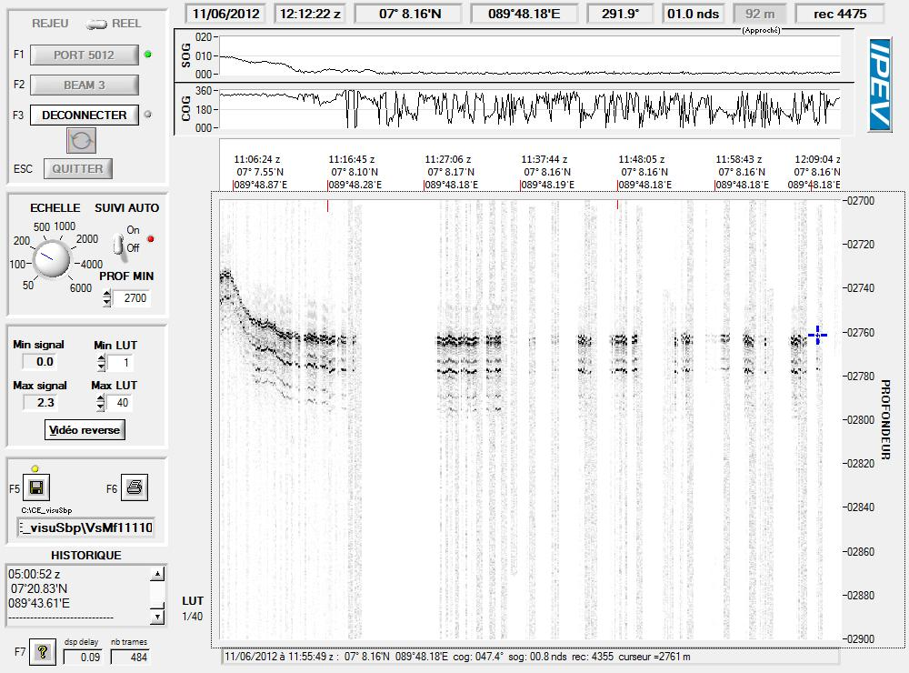
Figure: 3.5 kHz profile across station MONO 12 while arriving on site.

MD191 – MONOPOL | Station: MONO 12

CALYPSO CORING OPERATION:

Coring site information | Latitude (°N): | 7°08.18’
 | Longitude (°E): | 89°48.19’
 | Water depth (m): | 2760
Calypso corer settings | Core length (m): | 34.70
 | Empty weight in water (t): | 7.29
 | Free fall (m): | 3
 | Length piston cable (m): | 47.19
Coring operation | Time corer starts descent: | 11:56
 | Time triggering: | 13:00
 | Length cable (m): | 2715
 | Maximum tension (t) | 10.60
 | Time corer on deck: | 14:30
Result coring operation | Total weight in water (t) | 7.39
 | Length of sediment (m) | 0
General observations / incidents:
Carotte vide et pliée, ogive arrachée. =>completelyempty !

MD191 – MONOPOL | Station: MONO 12

PICTURES OF CALYPSO



