MD191 – MONOPOL | Station: MONO 11

STATION SUMMARY

Date and time approaching site: 10/6/2012 –6:45 (TU)
Date and time ending station activity:
Latitude: 8°17.77N Longitude: 89°23.10E Water depth (m): 3530
Short area description:“Fan-like” site, seen during S-N transect between MONO1 and MONO2, at beginning of cruise. Apparently, sediment cover expands (about x2) at this location.

Activity on station |  | Core identification
Calypso corer | Yes (2) | Calypso lost & MD12-3423
Casq | No
Multi-corer | No
Temp/Salinity/Fluorometry on coring device | No
CTD / Water sampling (rosette) | No
Deep In situ pump | Yes
Plankton net | No

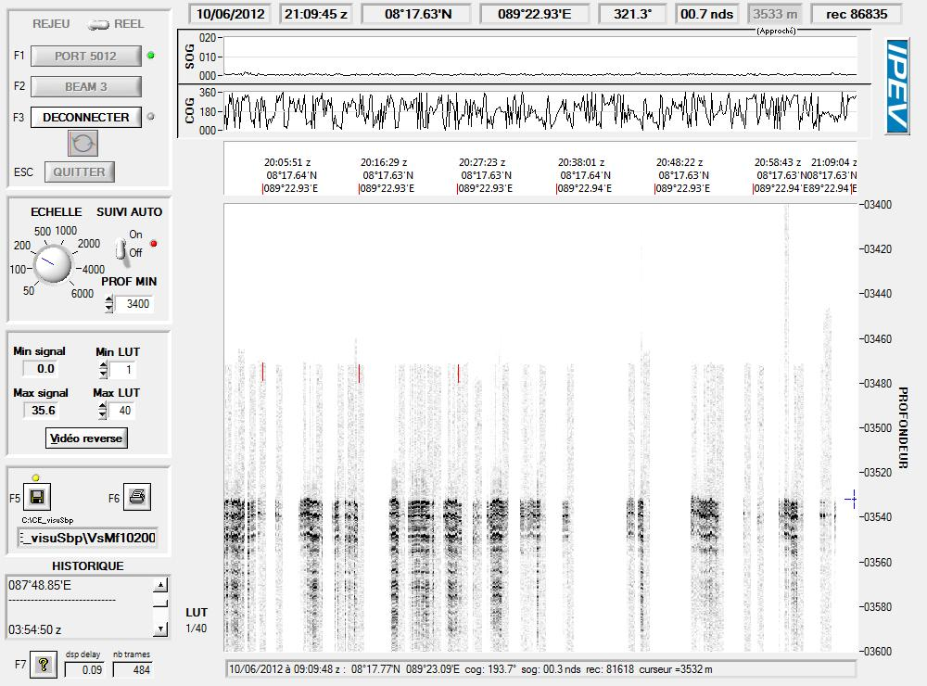

Figure: 3.5 kHz profile across station MONO 11.

MD191 – MONOPOL | Station:MONO 11

Deep ISP OPERATION

In-Situ Pumping (ISP)
Water depth of pumping (m) | 3000
Filtered volume (L) | 1010
Filter | Nucleopore 0.4 um
General observations / incidents:

MD191 – MONOPOL | Station: MONO 11

CALYPSO CORING OPERATION: MD12-3423

Coring site information | Latitude (°N): | 8°17.64
 | Longitude (°E): | 89°22.94
 | Water depth (m): | 3530
Calypso corer settings | Core length (m): | 34.7
 | Empty weight in water (t): | 7.29
 | Free fall (m): | 3
 | Length piston cable (m): | 47.30
Coring operation | Time corer starts descent: | 20:20
 | Time triggering: | 21:47
 | Length cable (m): | 3483
 | Maximum tension (t) | 12.95
 | Time corer on deck: | 00:00
Result coring operation | Total weight in water (t) | 7.74
 | Length of sediment (m)
General observations / incidents:
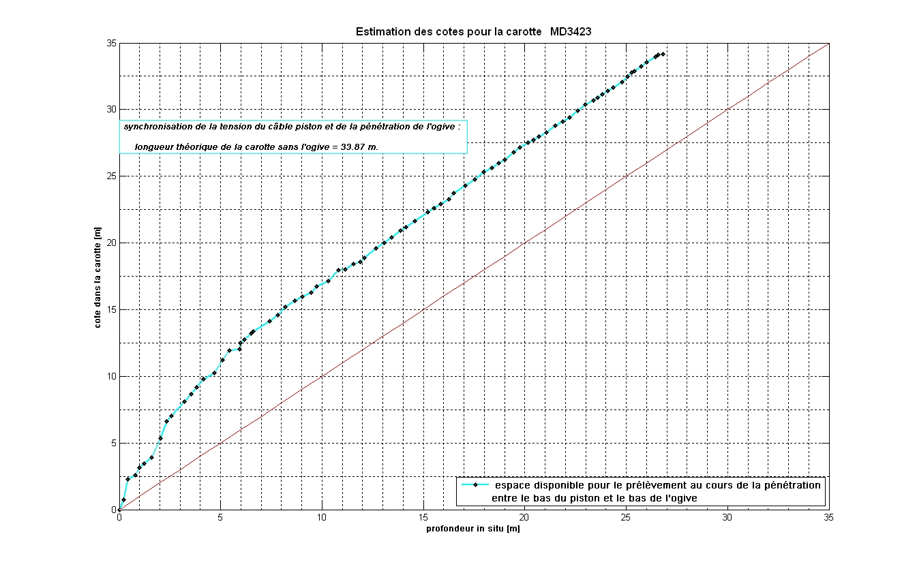First Calypso lost: handling chain broke.
Figure: Core level versus in situ sediment depth, CINEMA reconstructions for core MD12-3423.

MD191 – MONOPOL | Station: MONO 11

SECTIONS INFORMATIONS OF CALYPSO MD12-3423

Core MD12-3423 |  |  |  |  |  |  | MONOPOL -MD191
Section | Top depth (cm) | Bottom depth (cm) | Real length of section (cm) | Observations
I | 0 | 150 | 149.7 | -
II | 150 | 300 | 150.2 | -
III | 300 | 450 | 150.5 | -
IV | 450 | 600 | 150.6 | -
V | 600 | 750 | 150.1 | -
VI | 750 | 900 | 150.7 | -
VII | 900 | 1050 | 149.9 | -
VIII | 1050 | 1200 | 150.7 | -
IX | 1200 | 1350 | 150.1 | -
X | 1350 | 1500 | 150.3 | -
XI | 1500 | 1650 | 150.2 | -
XII | 1650 | 1800 | 150.6 | -
XIII | 1800 | 1950 | 150.2 | -
XIV | 1950 | 2100 | 150.6 | -
XV | 2100 | 2250 | 151.1 | -
XVI | 2250 | 2400 | 150.4 | Volcanic stone : 22.77cm
XVII | 2400 | 2550 | 150.1 | -
XVIII | 2550 | 2700 | 150.5 | -
XIX | 2700 | 2850 | 150.3 | -
XX | 2850 | 3000 | 150 | -
XXI | 3000 | 3150 | 150.6 | 3147-3150: empty
XXII | 3000 | 3172 | 21.4

General observations / incidents:

MD191 – MONOPOL | Station: MONO 11

PICTURES OF CALYPSO MD12-3423
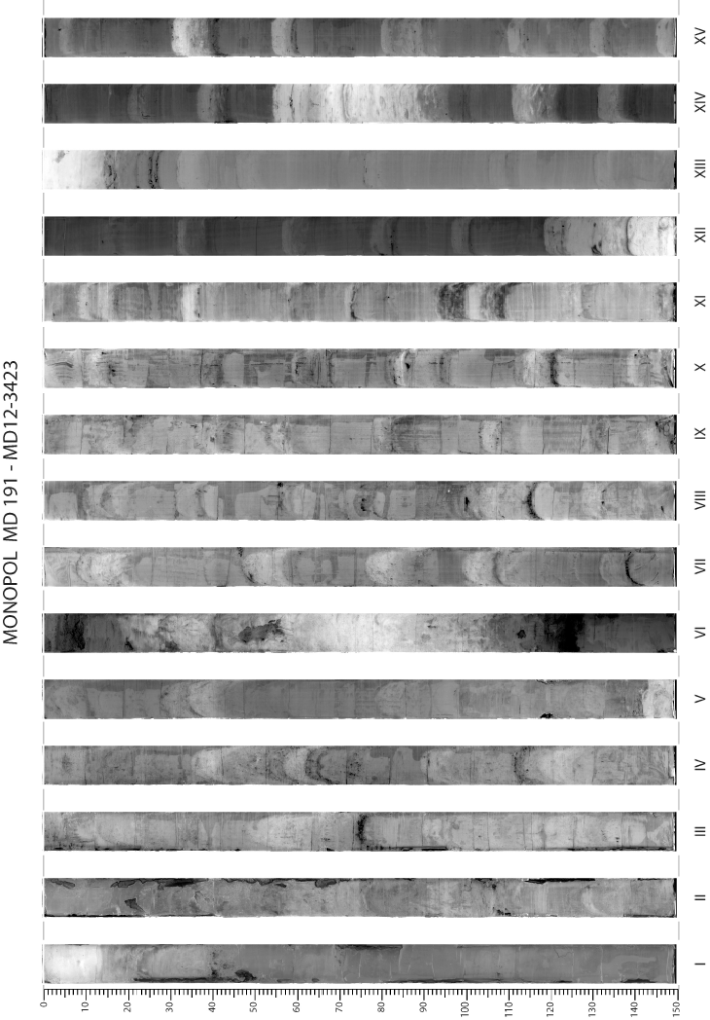

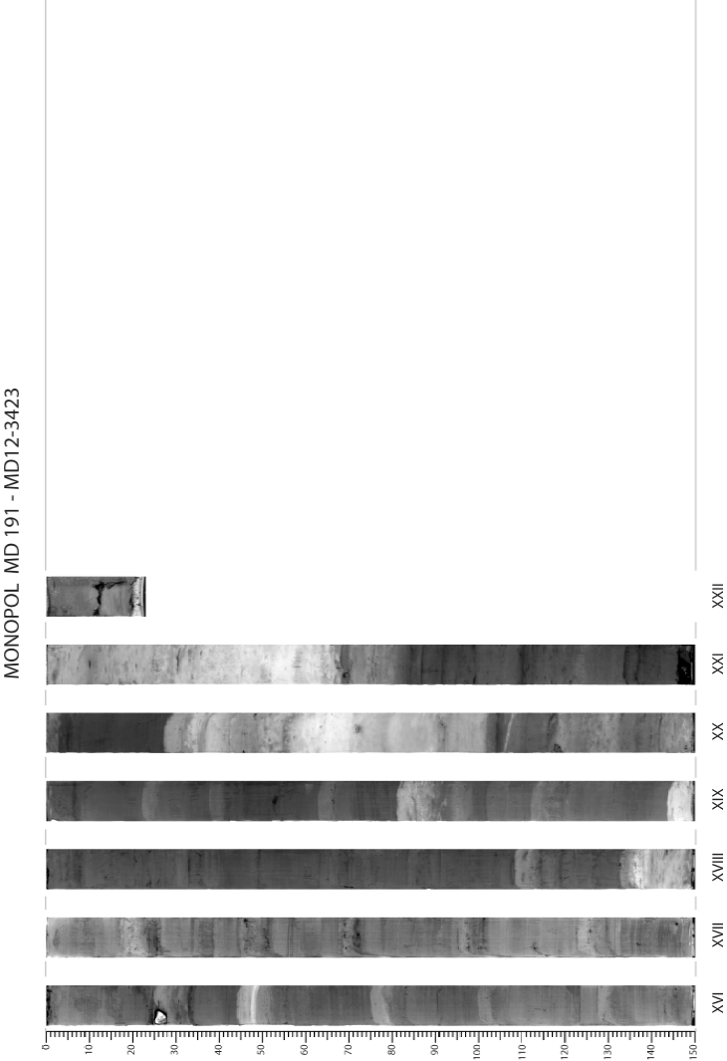
MD191 – MONOPOL | Station: MONO 11

PHYSICAL PROPERTIES OF CALYPSO MD12-3423
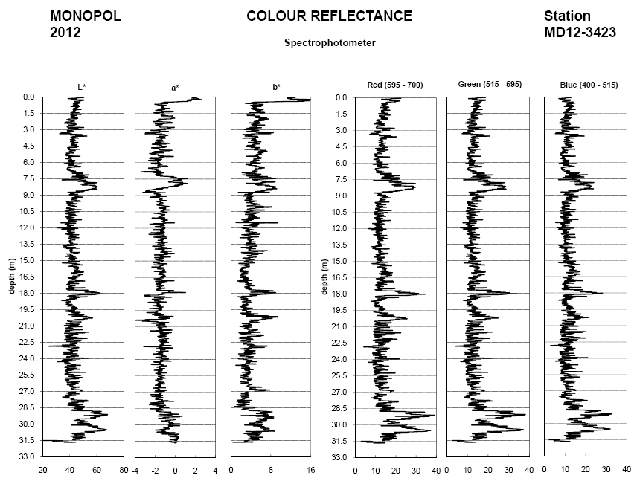
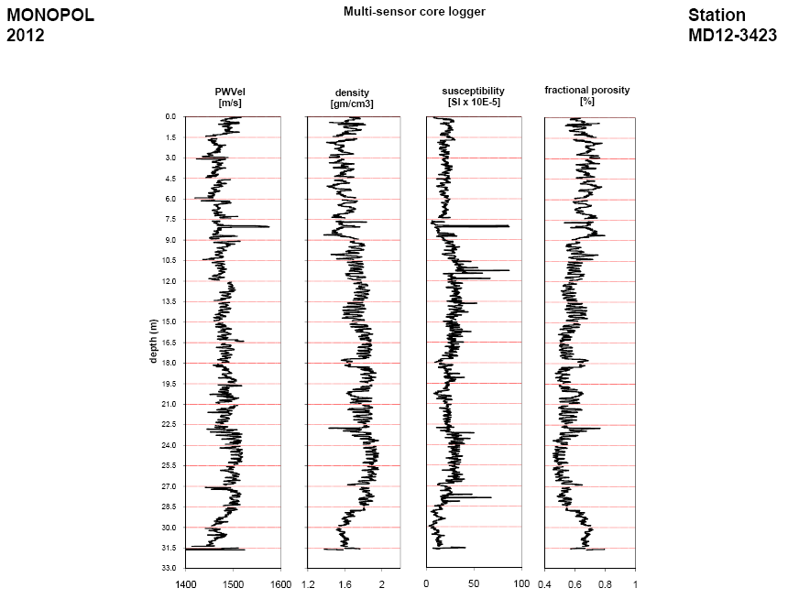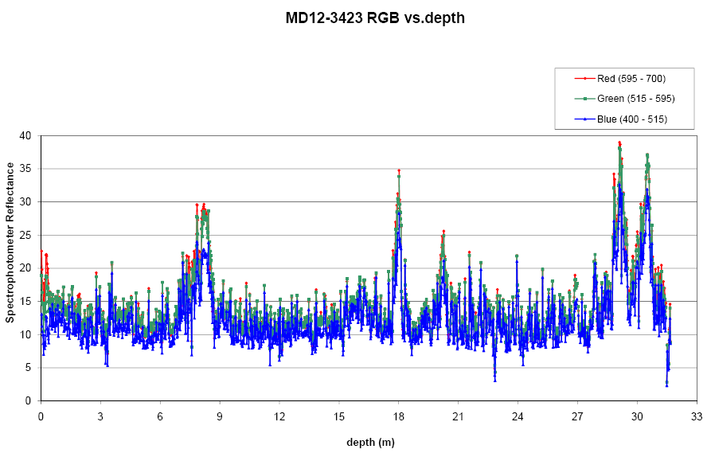
MD191 – MONOPOL | Station: MONO 11

SEDIMENTOLOGY OF CALYPSO MD12-3423


