MD191 – MONOPOL | Station: MONO 10

STATION SUMMARY

Date and time approaching site: 6/6/2012 –19:45 (TU)
Date and time ending station activity:
Latitude: 16°00.10N Longitude: 87°52.38E Water depth (m): 2660
Short area description:Site located in the distal levee, about 2km from the channel. The 3.5 kHz profile suggested about 100m of soft, sedimentary cover (no strong reflector). Coring showed fine sediments (clay with only a few, cm-thick silty layers).

Activity on station |  | Core identification
Calypso corer | Yes (2) | Calypso lost& MD12-3421
Casq | Yes | MD12-3420-CQ
Multi-corer | No
Temp/Salinity/Fluorometry on coring device | No
CTD / Water sampling (rosette) | No
Deep In situ pump | No
Plankton net | No

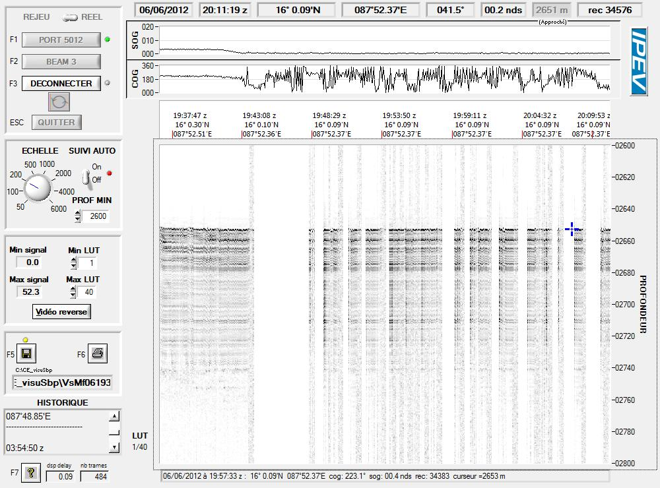
Figure: 3.5 kHz profile across station MONO 10.

MD191 – MONOPOL | Station: MONO 10

CASQ CORING OPERATION: MD12-3420-CQ

Coring site information | Latitude (°N): | 16°00.10N
 | Longitude (°E): | 87°52.37E
 | Water depth (m): | 2662
Casq corer settings | Core length (m): | 12
 | Empty weight in water (t): | 7.09
Coring operation | Time corer starts descent: | 20:46 TU
 | Time on bottom: | 21:45 TU
 | Maximum tension (t) | 14.1
 | Time corer on deck: | 23:50TU
Result coring operation | Total weight in water (t) | 7.62
 | Length of sediment (m) | 8.52

General observations / incidents:
Boue homogène sans niveau silteux. Quelques niveaux noirs => semblent être de la matière organique.
Semble bon pour test 42m.

MD191 – MONOPOL | Station: MONO 10

CALYPSO CORING OPERATION: MD12-3421

Coring site information | Latitude (°N): | 15°59.96N
 | Longitude (°E): | 87°52.53E
 | Water depth (m): | 2620
Calypso corer settings | Core length (m): | 35.10
 | Empty weight in water (t): | 7.13
 | Free fall (m): | 3
 | Length piston cable (m): | 47.57
Coring operation | Time corer starts descent: | 7:02TU
 | Time triggering: | 8:34 TU
 | Length cable (m): | 2589
 | Maximum tension (t) | 13.6
 | Time corer on deck: | 9:45
Result coring operation | Total weight in water (t) | 7.62
 | Length of sediment (m) | 31.40
General observations / incidents:
On s’est décalé un peu au SE du point de perte du premier carottier pour ne pas retaper dessus.
Carotte a bien pénétré. Arrêt sur piston en butée mais « molle » (pas à-coup final net)
Lecture des accéléros confirme que carotte a ralenti sur la fin => pas la peine de tenter plus long… cela ne rentrera pas (sauf si poids + lourd en tête).

Figure: Core levels versus in situ sediment depth, CINEMA reconstructions for core MD12-3421.

MD191 – MONOPOL | Station: MONO 10

SECTIONS INFORMATIONS OF CASQ MD12-3420-CQ

Number of layers (2 or 3):
Sketch of the core section, defining the location of liners A, B, C, D :

B
A

C
D

Liner A : large size (12 cm)
Liners B, C : medium size (6 cm)
Liners D : small U-channel (pris de 3.96 à la base pour J-P Valet)

SECTIONS INFORMATIONS OF CASQ MD12-3420 CQ
Core MD12-3420 CQ |  |  |  |  |  |  | MONOPOL -MD191
Section | Top depth (cm) | Bottom depth (cm) | Real length of section (cm) | Observations
I | 0 | 150 | 149.2
II | 150 | 300 | 149.6
III | 300 | 450 | 149.6
IV | 450 | 600 | 149.7
V | 600 | 750 | 149.6
VI | 750 | 851 | 149.4 | Photo dans section 150cm, mais 101cm de sédiment

MD191 – MONOPOL | Station: MONO 10

PICTURES OF CASQ MD12-3420-CQ

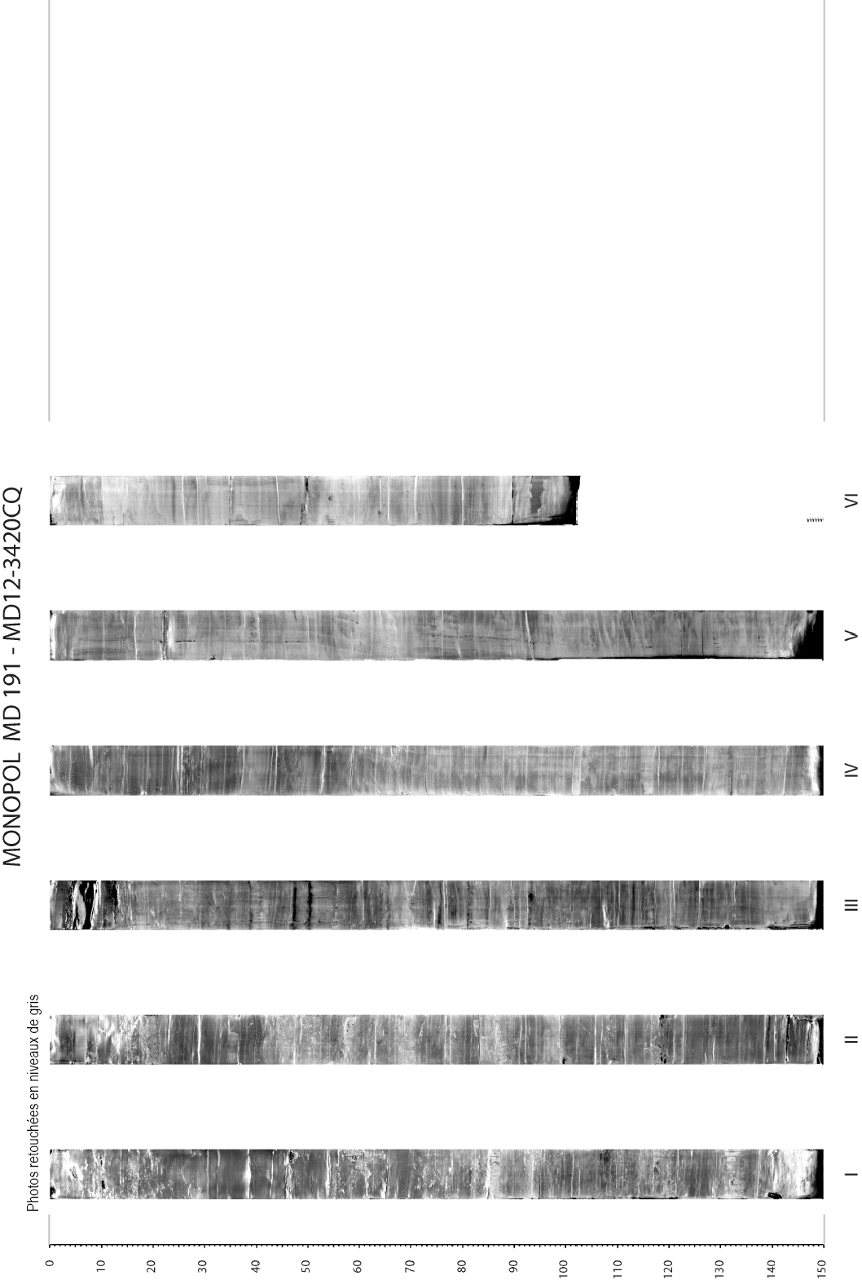
MD191 – MONOPOL | Station: MONO 10

PHYSICAL PROPERTIES OF CASQ MD12-3420 -CQ
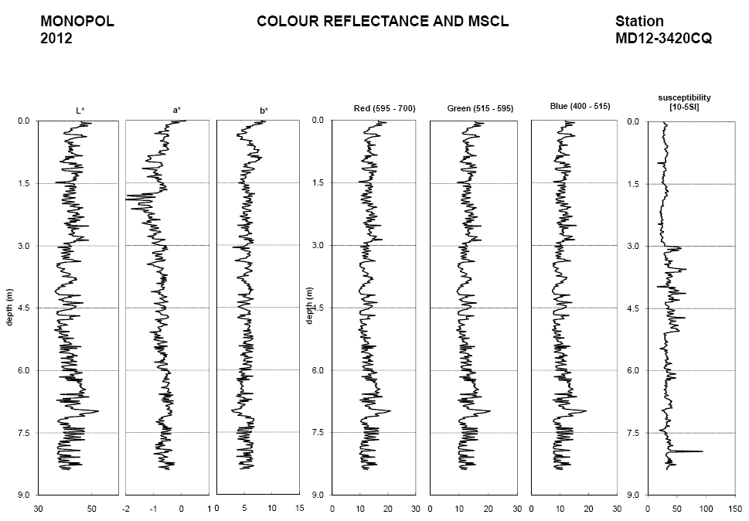
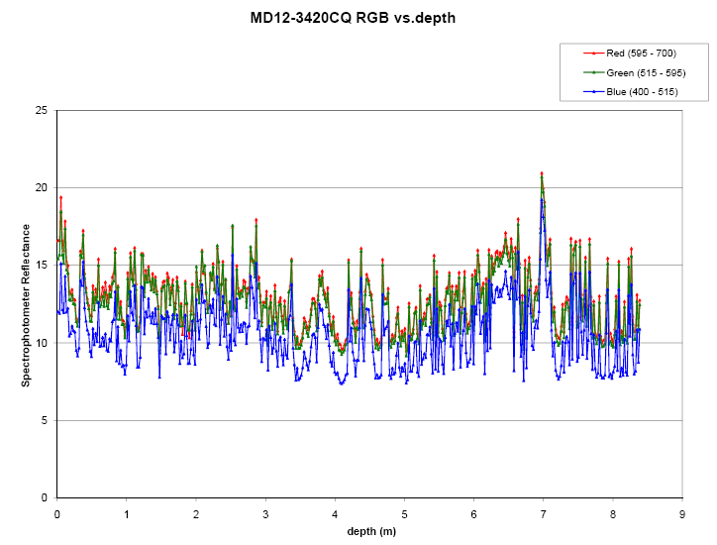

Figure: Color reflectance and physical properties of CASQ core MD12-3420 CQ

MD191 – MONOPOL | Station: MONO 10

SEDIMENTOLOGY OF CASQ CORE MD12-3420-CQ
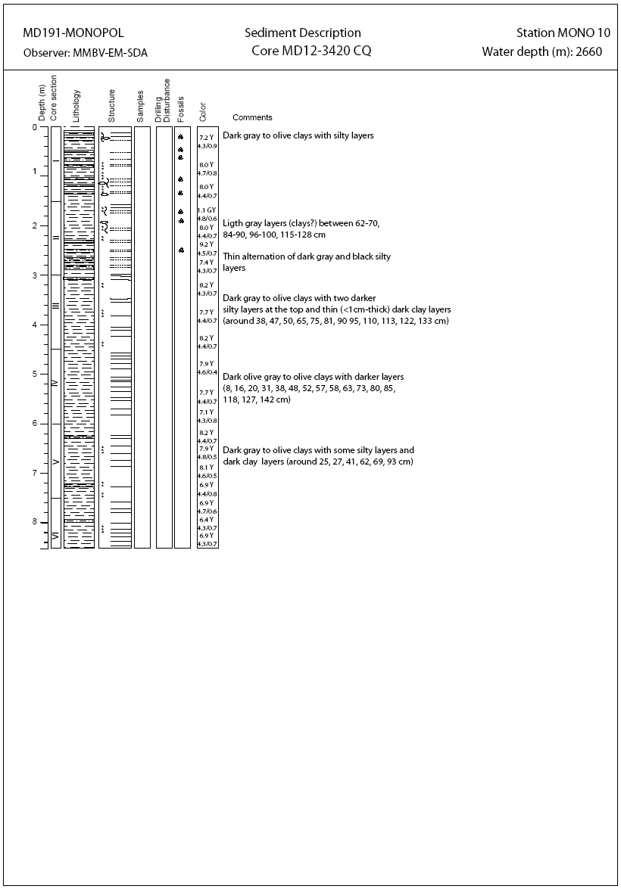

MD191 – MONOPOL | Station: MONO 10

SECTIONS INFORMATIONS OF CALYPSO MD12-3421

Core MD12-3421 |  |  |  |  |  |  | MONOPOL -MD191
Section | Top depth (cm) | Bottom depth (cm) | Real length of section (cm) | Observations
I | 0 | 150 | 150.9 | -
II | 150 | 300 | 150.8 | -
III | 300 | 450 | 150.4 | -
IV | 450 | 600 | 150.5 | -
V | 600 | 750 | 150.1 | -
VI | 750 | 900 | 150.1 | -
VII | 900 | 1050 | 150.5 | -
VIII | 1050 | 1200 | 151 | -
IX | 1200 | 1350 | 150.7 | -
X | 1350 | 1500 | 150.4 | -
XI | 1500 | 1650 | 150.6 | -
XII | 1650 | 1800 | 150.7 | -
XIII | 1800 | 1950 | 151 | -
XIV | 1950 | 2100 | 151.1 | -
XV | 2100 | 2250 | 150.8 | -
XVI | 2250 | 2400 | 150.3 | -
XVII | 2400 | 2550 | 150.6 | -
XVIII | 2550 | 2700 | 150 | -
XIX | 2700 | 2850 | 150.4 | -
XX | 2850 | 3000 | 149.8 | -
XXI | 3000 | 3150 | 141 | Polystyren: 95-105

General observations / incidents:
Calibration de la photo a dû être refaite.

MD191 – MONOPOL | Station: MONO 10

PICTURES OF CALYPSO MD12-3421
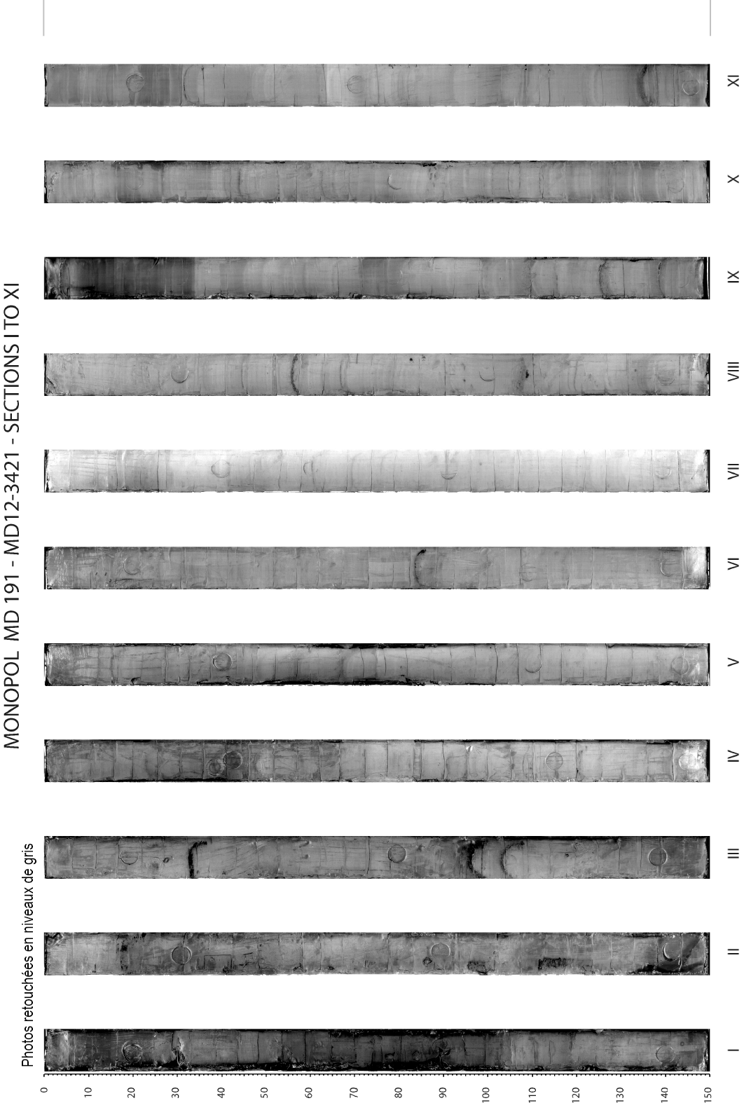
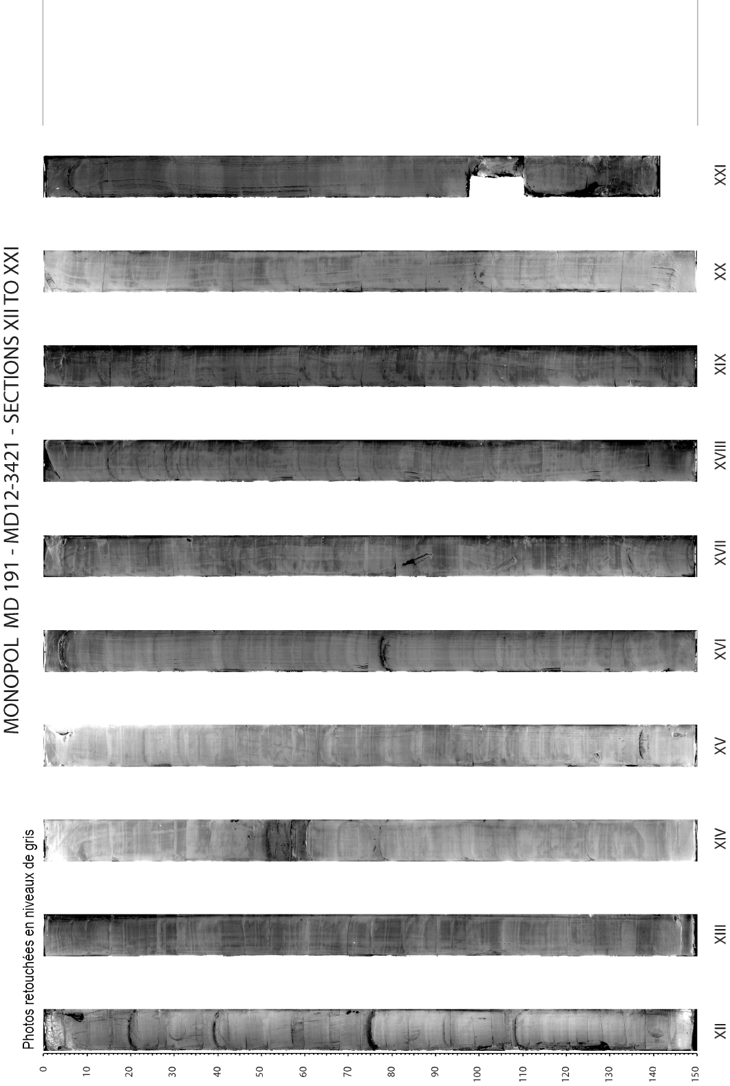

MD191 – MONOPOL | Station: MONO 10

PHYSICAL PROPERTIES OF CALYPSO MD12-3421
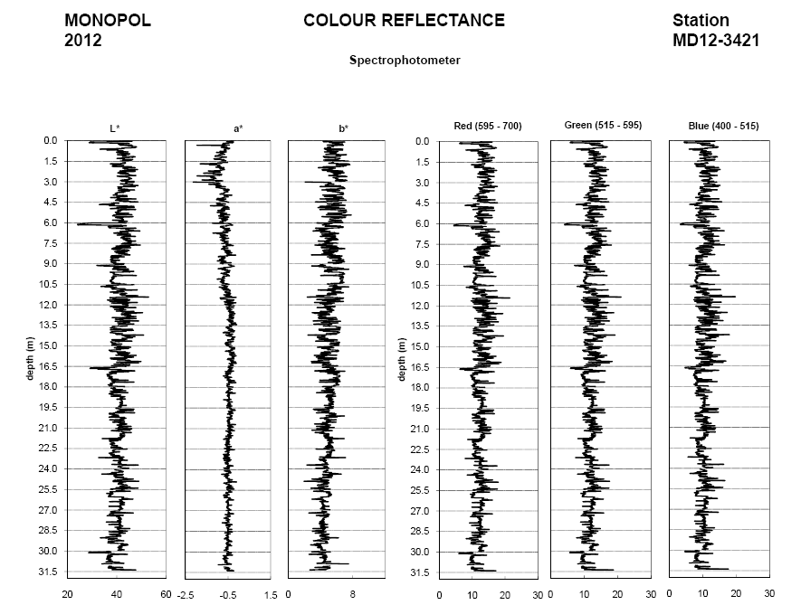
hole in sediment
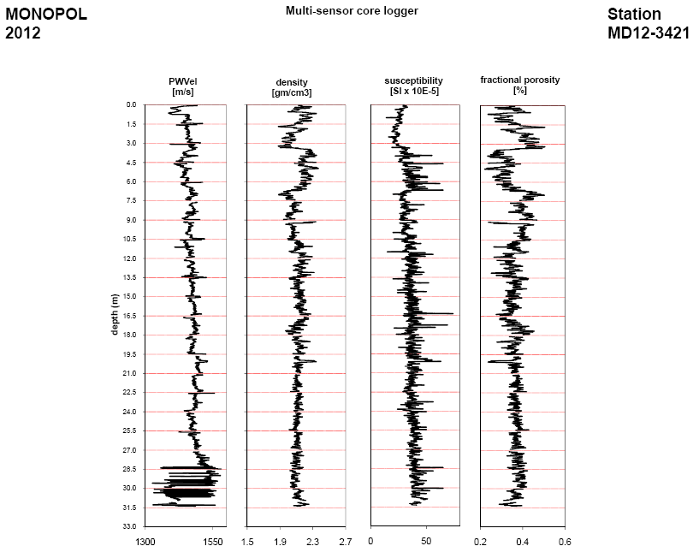
hole in sediment
MD191 – MONOPOL | Station: MONO 10

SEDIMENTOLOGY OF CALYPSO MD12-3421



