MD191 – MONOPOL | Station: MONO 9

STATION SUMMARY

Date and time approaching site: 6/6/2012 –6:08 (TU)
Date and time ending station activity:6:6/2012 – 16:35 (TU)
Latitude:16°14.54N Longitude: 87°54.70E Water depth (m): 2610
Short area description:Sedimentary levee with a few strong 3.5 kHz reflectors. CASQ core revealed numerous silty layers (turbidites), from 1-2 cm up to 20 cm thick. This stiff layers probably explained the relatively short penetration of the CASQ (only about 6m). Decision to abort CALYPSO coring operations..

Activity on station |  | Core identification
Calypso corer | No
Casq | Yes | MD12-3419-CQ
Multi-corer | Yes | MD191-MC-MONO9
Temp/Salinity/Fluorometry on coring device | No
CTD / Water sampling (rosette) | Yes
Deep In situ pump | No
Plankton net | Yes

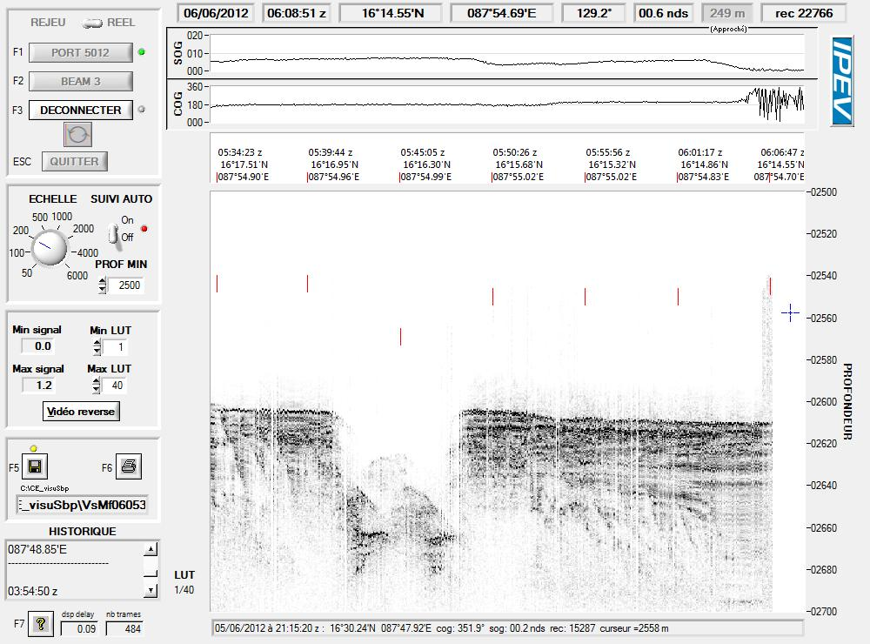

Figure: 3.5 kHz profile across station MONO 9 while arriving on site.

MD191 – MONOPOL | Station: MONO 9

CASQ CORING OPERATION: MD12-3419-CQ

Coring site information | Latitude (°N): | 16°14.63N
 | Longitude (°E): | 87°54.67E
 | Water depth (m): | 2614
Casq corer settings | Core length (m): | 9
 | Empty weight in water (t): | 6.83
Coring operation | Time corer starts descent: | 13:49 TU
 | Time on bottom: | 14:39 TU
 | Maximum tension (t) | 11.2
 | Time corer on deck: | 16:00TU
Result coring operation | Total weight in water (t) | 7.25
 | Length of sediment (m) | 6.85

General observations / incidents:
Nombreux niveaux de siets assez compacts (turbidites) dont un premier niveau vers 3m qui fait 15-20cm.
Le CASQ 9m ne s’est planté que de 6m => suspicion d’un niveau compact à la base et peut-être CQ freiné par le nombre de turbidites.
=> Ce sédiment semble peu propice à du carottage long. On ne peut pas y faire les tests du CALYPSO avec tubes 42m… et encore moins carotter 60m.
=> ABANDON du site pour aller plus au sud sur levée avec épaisse couche fine (3.5 kHz).

MULTI-CORER OPERATION: MD191-MC-MONO9

Coring site information | Latitude (°N): | 16°14.63N
 | Longitude (°E): | 87°54.66E
 | Water depth (m): | 2608
Coring operation | Time multi corer starts descent: | 10:58 TU
 | Time at bottom: | 11:48 TU
 | Time corer on deck: | 12:48 TU
Length of sediments (cm) | Tube 1 | 42
 | Tube 2 | 44
 | Tube 3 | 42
 | Tube 4 | ~42

General observations / incidents:
4 tubes pleins : magnifique !
Echantillonnage de l’eauinterstitielle (PW) a réussi.
Echantillonnage de l’eau de surface a réussi.
Pour la première fois on a récupéré les 4 tubes identiques, bonnequalité de sédiment.

MD191 – MONOPOL | Station:MONO 9

CTD/ROSETTE/ISP OPERATION

CTD/Rosette site information | Latitude (°N): | 16°14.57’N
 | Longitude (°E): | 87°54.69’E
CTD/Rosette operation | Time CTD/rosette starts descent: | 6:33 TU
 | Time on bottom: | ?
 | Time on deck: | 8:30 TU
Depth of Water sampling | Bottle 1 | 2592
 | Bottle 2 | 2592
 | Bottle 3 | 2572
 | Bottle 4 | 2500
 | Bottle 5 | 2200
 | Bottle 6 | 1500
 | Bottle 7 | 1500
 | Bottle 8 | 900
 | Bottle 9 | -
 | Bottle 10 | 500
 | Bottle 11 | 300
 | Bottle 12 | 180
 | Bottle 13 | -
 | Bottle 14 | 160
 | Bottle 15 | 140
 | Bottle 16 | 110
 | Bottle 17 | 90
 | Bottle 18 | 70
 | Bottle 19 | 50
 | Bottle 20 | 40
 | Bottle 21 | 30
 | Bottle 22 | 20
 | Bottle 23 | 10
 | Bottle 24 | 5

MULTI-NET OPERATION
 |  | First deployement | Second deployement
Coring site information | Latitude (°N): | 16.24° N | 16.24° N
 | Longitude (°E): | 87.91° E | 87.91° E
Coring operation | Time start operation: | 9:24 | 10:03
 | Time net on deck: | 9:41 | 10:10
Depth of multinet collection (m) | Collector 1 | 400-180 | 100-80
 | Collector 2 | 180-80 | 80-60
 | Collector 3 | 80-60 | 60-40
 | Collector 4 | 60-40 | 40-20
 | Collector 5 | 40-0 | 20-0
General observations / incidents:

MD191 – MONOPOL | Station: MONO 9

CTD PROFILES

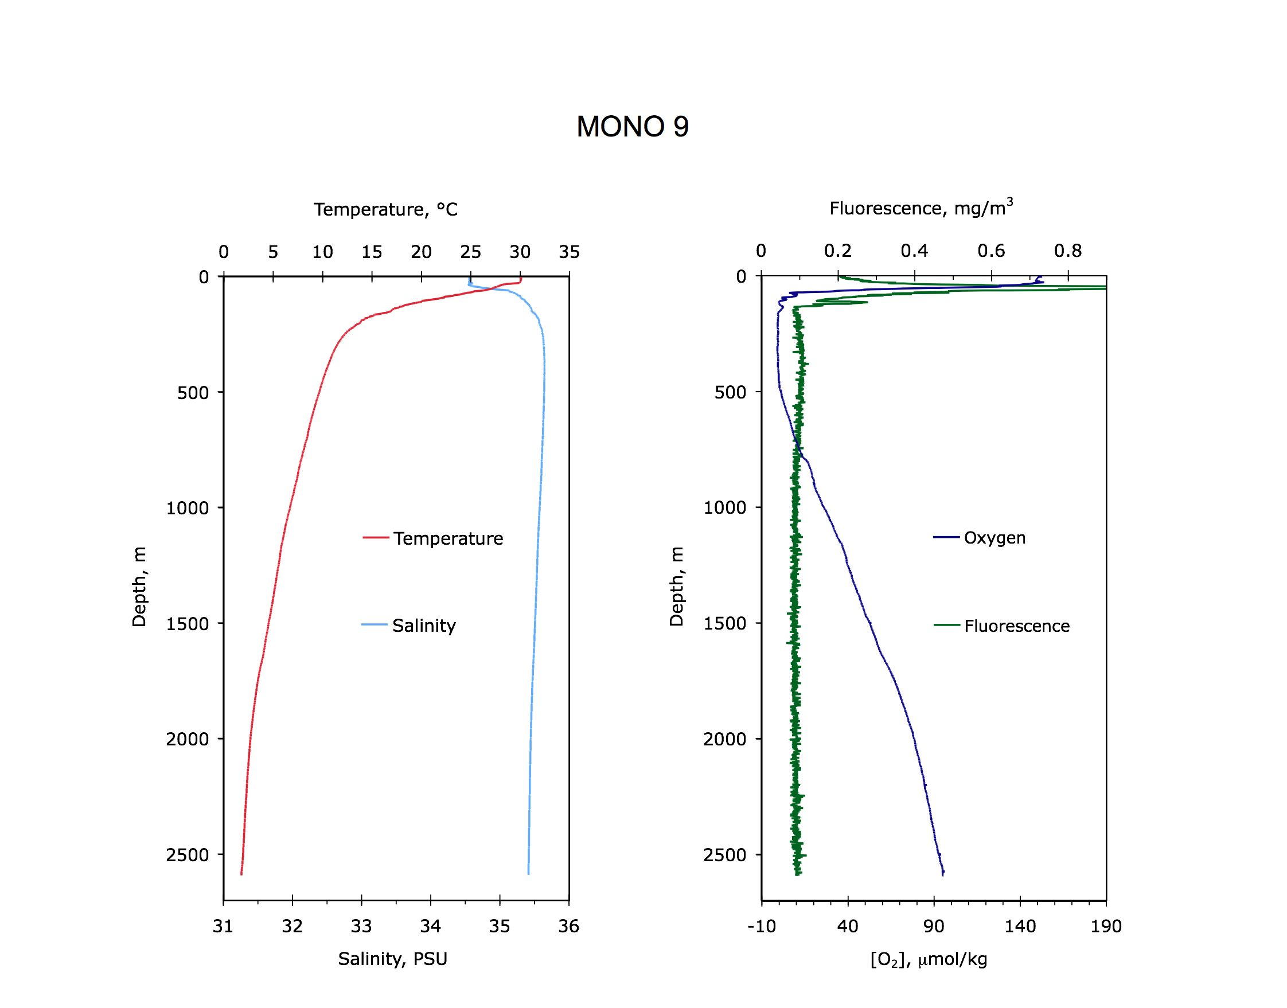

Figure: Temperature, salinity, fluorescence and dissolved oxygen profiles at site MONO 9.

MD191 – MONOPOL | Station: MONO 9

SECTIONS INFORMATIONS OF CASQ MD12-3419-CQ

Number of layers (2 or 3):
Sketch of the core section, defining the location of liners A, B, C, D, E :

B
A

C

E
D

Liner A, D : large size
Liners B, E : medium size
Liners C : small U-channel

SECTIONS INFORMATIONS OF CASQ MD12-3419 CQ
Core MD12-3419 CQ |  |  |  |  |  |  | MONOPOL -MD191
Section | Top depth (cm) | Bottom depth (cm) | Real length of section (cm) | Observations
I | 0 | 150 | 148.9 | -
II | 150 | 300 | 149.3 | -
III | 300 | 450 | 150.3 | -
IV | 450 | 600 | 150.6 | -
V | 600 | 750 | 149.1 | -
VI | 750 | 836 | ?? | -

MD191 – MONOPOL | Station: MONO 9

PICTURES OF CASQ MD12-3419-CQ

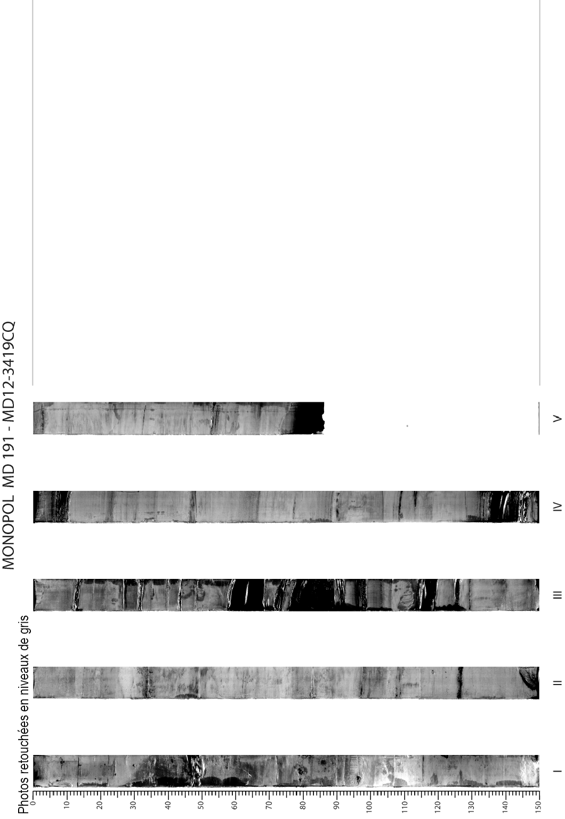
MD191 – MONOPOL | Station: MONO 9

PHYSICAL PROPERTIES OF CASQ MD12-3419 -CQ
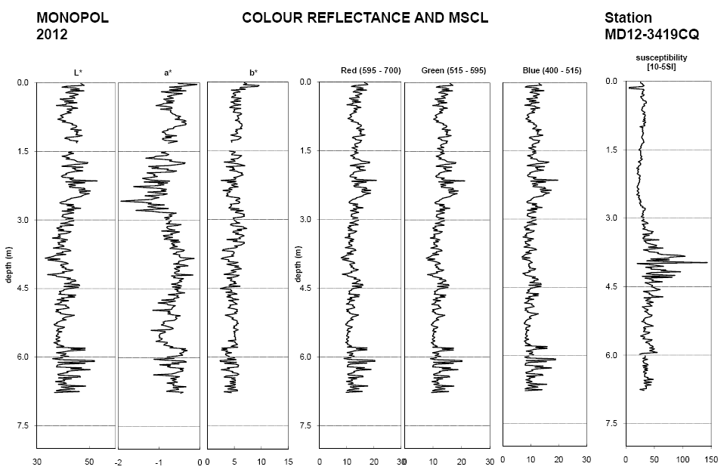

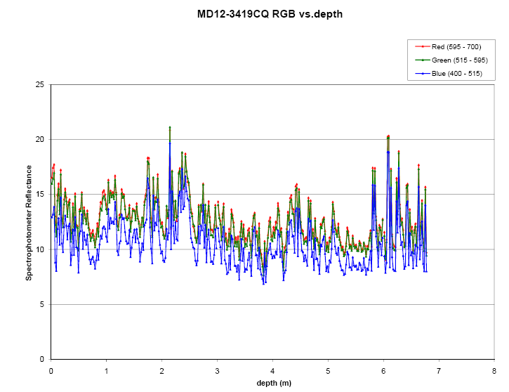

Figure: Color reflectance and physical properties of CASQ core MD12-3419 CQ

MD191 – MONOPOL | Station: MONO 9

SEDIMENTOLOGY OF CASQ CORE MD12-3419-CQ


