MD191 – MONOPOL | Station: MONO 8

STATION SUMMARY

Date and time approaching site: 4/6/2012 – 3:19 (TU)
Date and time ending station activity:27/5/2012 – 19:50 (TU)
Latitude:16°30.25N Longitude: 87°47.80E Water depth (m): 2560
Short area description:Close to site of core SONNE 118KL (10m). Active channel system with thick Holocene levees.

Activity on station |  | Core identification
Calypso corer | Yes (2) | MD12-3417& MD12-3422
Casq | Yes (2) | MD12-3416CQ& MD12-3418CQ
Multi-corer | Yes | MD191-MC-MONO8
Temp/Salinity/Fluorometry on coring device | No
CTD / Water sampling (rosette) | No
Deep In situ pump | No
Plankton net | No

Figure: 3.5 kHz profile across station MONO 8 while arriving on site.

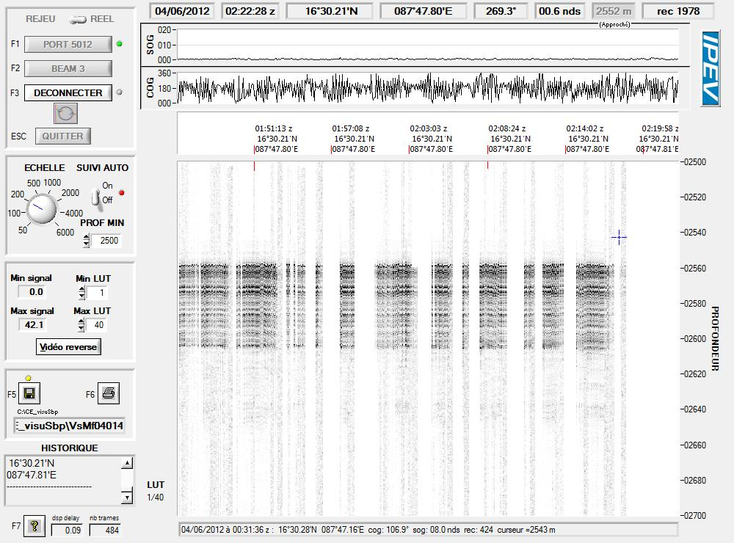
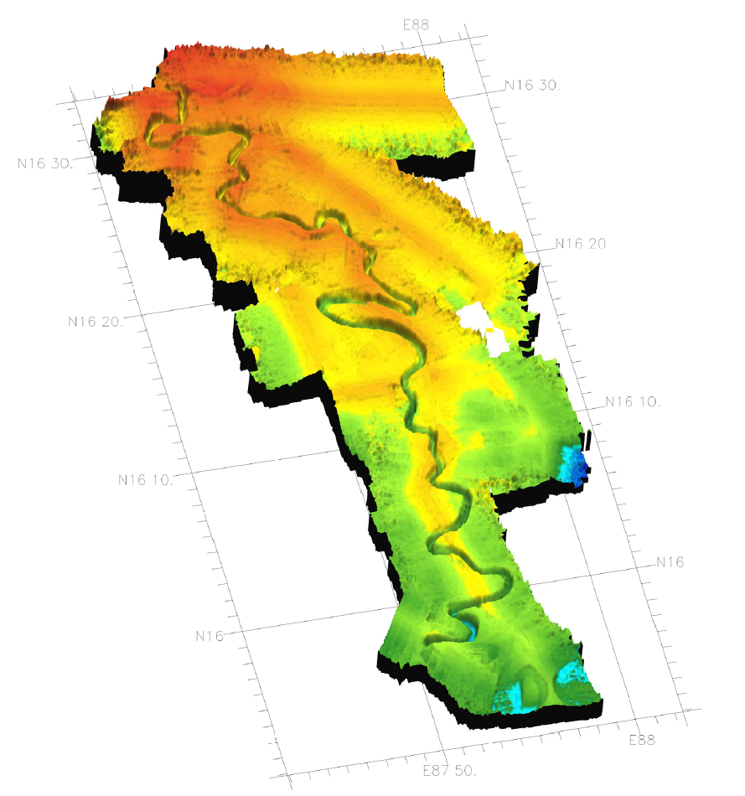
MD191 – MONOPOL | Station: MONO 8

CALYPSO CORING OPERATION: MD12-3417

Coring site information | Latitude (°N): | 16°30.03N
 | Longitude (°E): | 87°47.82E
 | Water depth (m): | 2564
Calypso corer settings | Core length (m): | 41.8
 | Empty weight in water (t): | 7.40
 | Free fall (m): | 3
 | Length piston cable (m): | 54.39
Coring operation | Time corer starts descent: | 8:59TU
 | Time triggering: | 10:00 TU
 | Length cable (m): | 2514
 | Maximum tension (t) | 11.7
 | Time corer on deck: | 11:10 TU
Result coring operation | Total weight in water (t) | 7.73
 | Length of sediment (m) | 39.77
General observations / incidents:

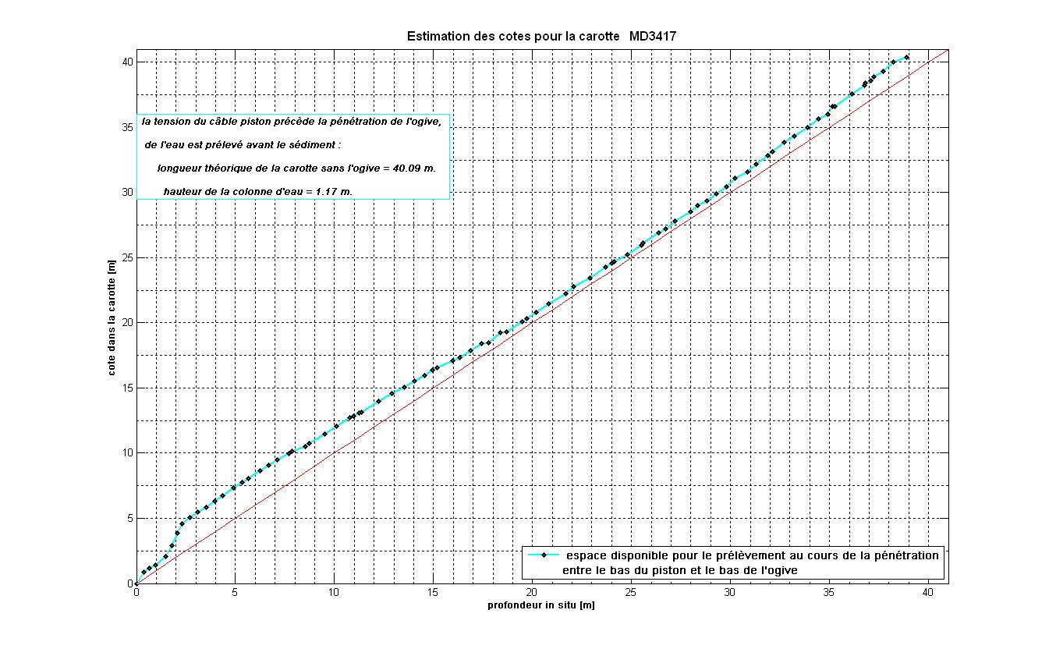Figure: Core levels versus in situ sediment depth, CINEMA reconstructions for core MD12-3417.

MD191 – MONOPOL | Station: MONO 8

CALYPSO CORING OPERATION: MD12-3422

Coring site information | Latitude (°N): | 16°30.20N
 | Longitude (°E): | 87°47.87E
 | Water depth (m): | 2558
Calypso corer settings | Core length (m): | 52
 | Empty weight in water (t): | 8
 | Free fall (m): | 3
 | Length piston cable (m): | 64.85
Coring operation | Time corer starts descent: | 15:52 TU
 | Time triggering: | 17:11 TU
 | Length cable (m): | 2508
 | Maximum tension (t) | 14.5
 | Time corer on deck: | 18:15 TU
Result coring operation | Total weight in water (t) | 8.25
 | Length of sediment (m) | 29.90
General observations / incidents:
Carottetordue : ~30m de sédiment

Figure: Core levels versus in situ sediment depth, CINEMA reconstructions for core MD12-3422.
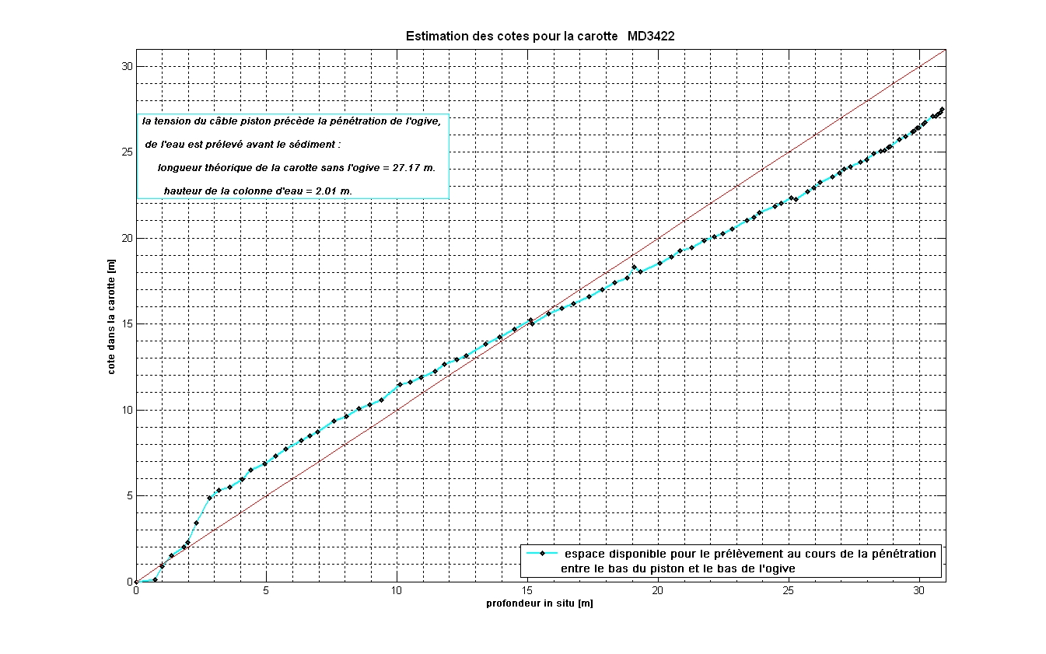
MD191 – MONOPOL | Station: MONO 8

CASQ CORING OPERATION: MD12-3416-CQ

Coring site information | Latitude (°N): | 16°30.25N
 | Longitude (°E): | 87°47.80E
 | Water depth (m): | 2564
Casq corer settings | Core length (m): | 12
 | Empty weight in water (t): | 7.32
Coring operation | Time corer starts descent: | 2:37 TU
 | Time on bottom: | 3:19 TU
 | Maximum tension (t) | 12.5
 | Time corer on deck: | 4:25 TU
Result coring operation | Total weight in water (t) | 7.90
 | Length of sediment (m) | 6.98
General observations / incidents:
Ouverture : Bouée qui doit maintenir le sommet n’a pas tenu (percée) -> tous les premiers mètres (2-3) ont flué. Mélange ?

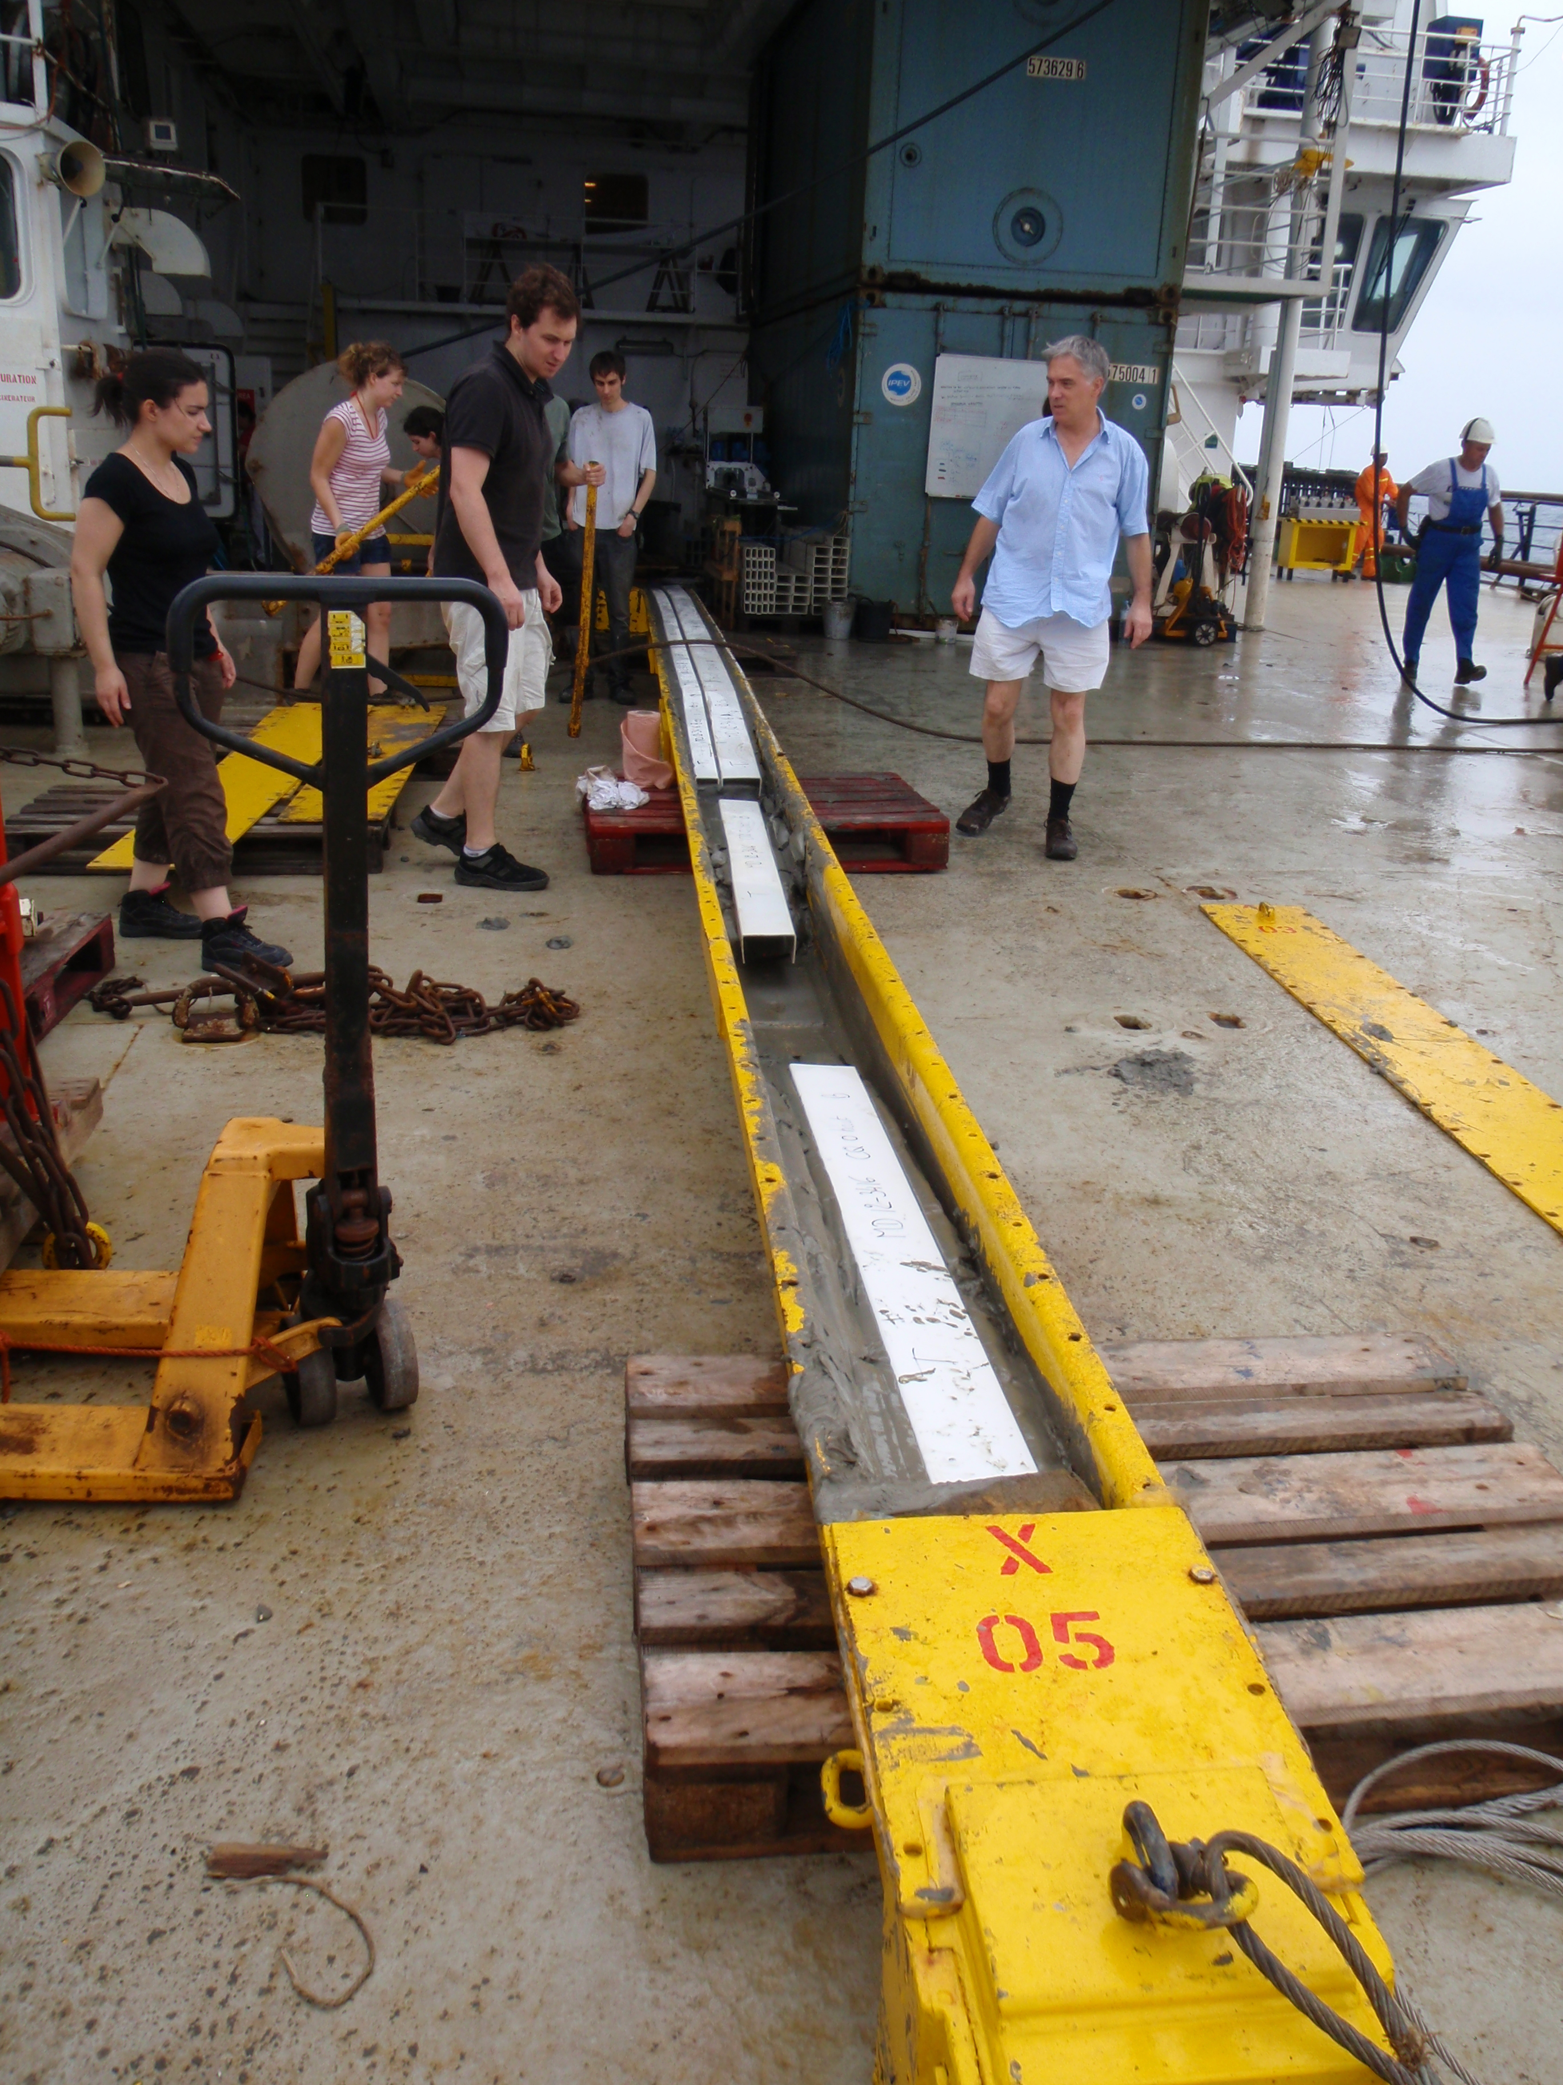
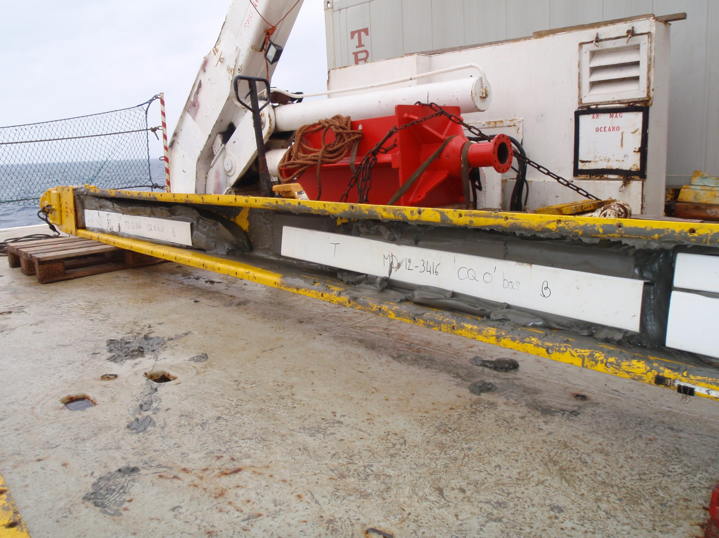
MD191 – MONOPOL | Station: MONO 8

CASQ CORING OPERATION: MD12-3418-CQ

Coring site information | Latitude (°N): | 16°30.27N
 | Longitude (°E): | 87°47.92E
 | Water depth (m): | 2557
Casq corer settings | Core length (m): | 12
 | Empty weight in water (t): | 7.30
Coring operation | Time corer starts descent: | 1:15 TU
 | Time on bottom: | 2:16 TU
 | Maximum tension (t) | 14.2
 | Time corer on deck: | 3:15 TU
Result coring operation | Total weight in water (t) | 7.90
 | Length of sediment (m) | 8.52
General observations / incidents:

MULTI-CORER OPERATION: MD191-MC-MONO8

Coring site information | Latitude (°N): | 16°30.28N
 | Longitude (°E): | 87°47.92E
 | Water depth (m): | 2549
Coring operation | Time multi corer starts descent: | 22:41 TU
 | Time at bottom: | 23:46 TU
 | Time corer on deck: | 0:39 TU
Length of sediments (cm) | Tube 1 | 32
 | Tube 2 | 29
 | Tube 3 | 52
 | Tube 4 | ~52

General observations / incidents:
Un premier MC qui n’a pas fonctionné : tubes beurrés de sédiments (pénétration) mais vides. Bout orange a gêné la fermeture des tubes (bati pas remonté totalement).
Deuxième MC fonctionne : MC12 – MONO8.
Echantillonnage de l’eauinterstitielle (PW) a réussi.
Echantillonnage de l’eau de surface a réussi.
A partir de ce MC, on a ajoutéuneplateformelourde, et la qualités’estaméliorée pour lesédiment et l’interface de l’eau.

MD191 – MONOPOL | Station: MONO 8

SECTIONS INFORMATIONS OF CALYPSO MD12-3417

Core MD12-3417 |  |  |  |  |  |  | MONOPOL -MD191
Section | Top depth (cm) | Bottom depth (cm) | Real length of section (cm) | Observations
I | 0 | 150 | 149.9
II | 150 | 300 | 151.9
III | 300 | 450 | 151.3
IV | 450 | 600 | 150.6
V | 600 | 750 | 150.4
VI | 750 | 900 | 150.7 | 864 – 872 :small holes
VII | 900 | 1050 | 151
VIII | 1050 | 1200 | 150.4
IX | 1200 | 1350 | 150.4 | Polystyren : 1335 - 1350
X | 1350 | 1500 | 149.9
XI | 1500 | 1650 | 150.7
XII | 1650 | 1800 | 150.4
XIII | 1800 | 1950 | 150.2
XIV | 1950 | 2100 | 151.4
XV | 2100 | 2250 | 150.7
XVI | 2250 | 2400 | 151.2
XVII | 2400 | 2550 | 150.5
XVIII | 2550 | 2700 | 150.3
XIX | 2700 | 2850 | 150.4
XX | 2850 | 3000 | 150.9
XXI | 3000 | 3150 | 150.4
XXII | 3150 | 3300 | 150.9
XXIII | 3300 | 3450 | 150.6
XXIV | 3450 | 3600 | 150.6
XXV | 3600 | 3750 | 150.1
XXVI | 3750 | 3900 | 150.7
XXVII | 3900 | 3977 | 77.6

MD191 – MONOPOL | Station: MONO 8

PICTURES OF CALYPSO MD12-3417
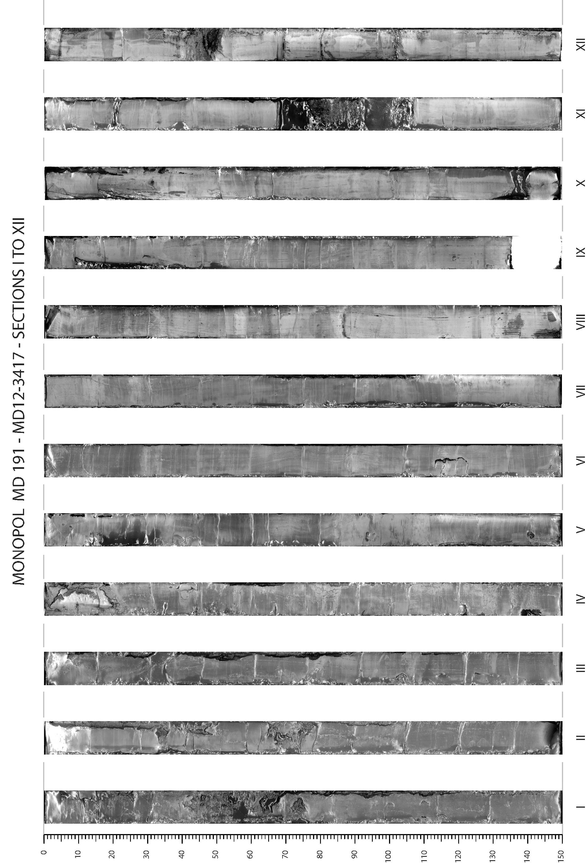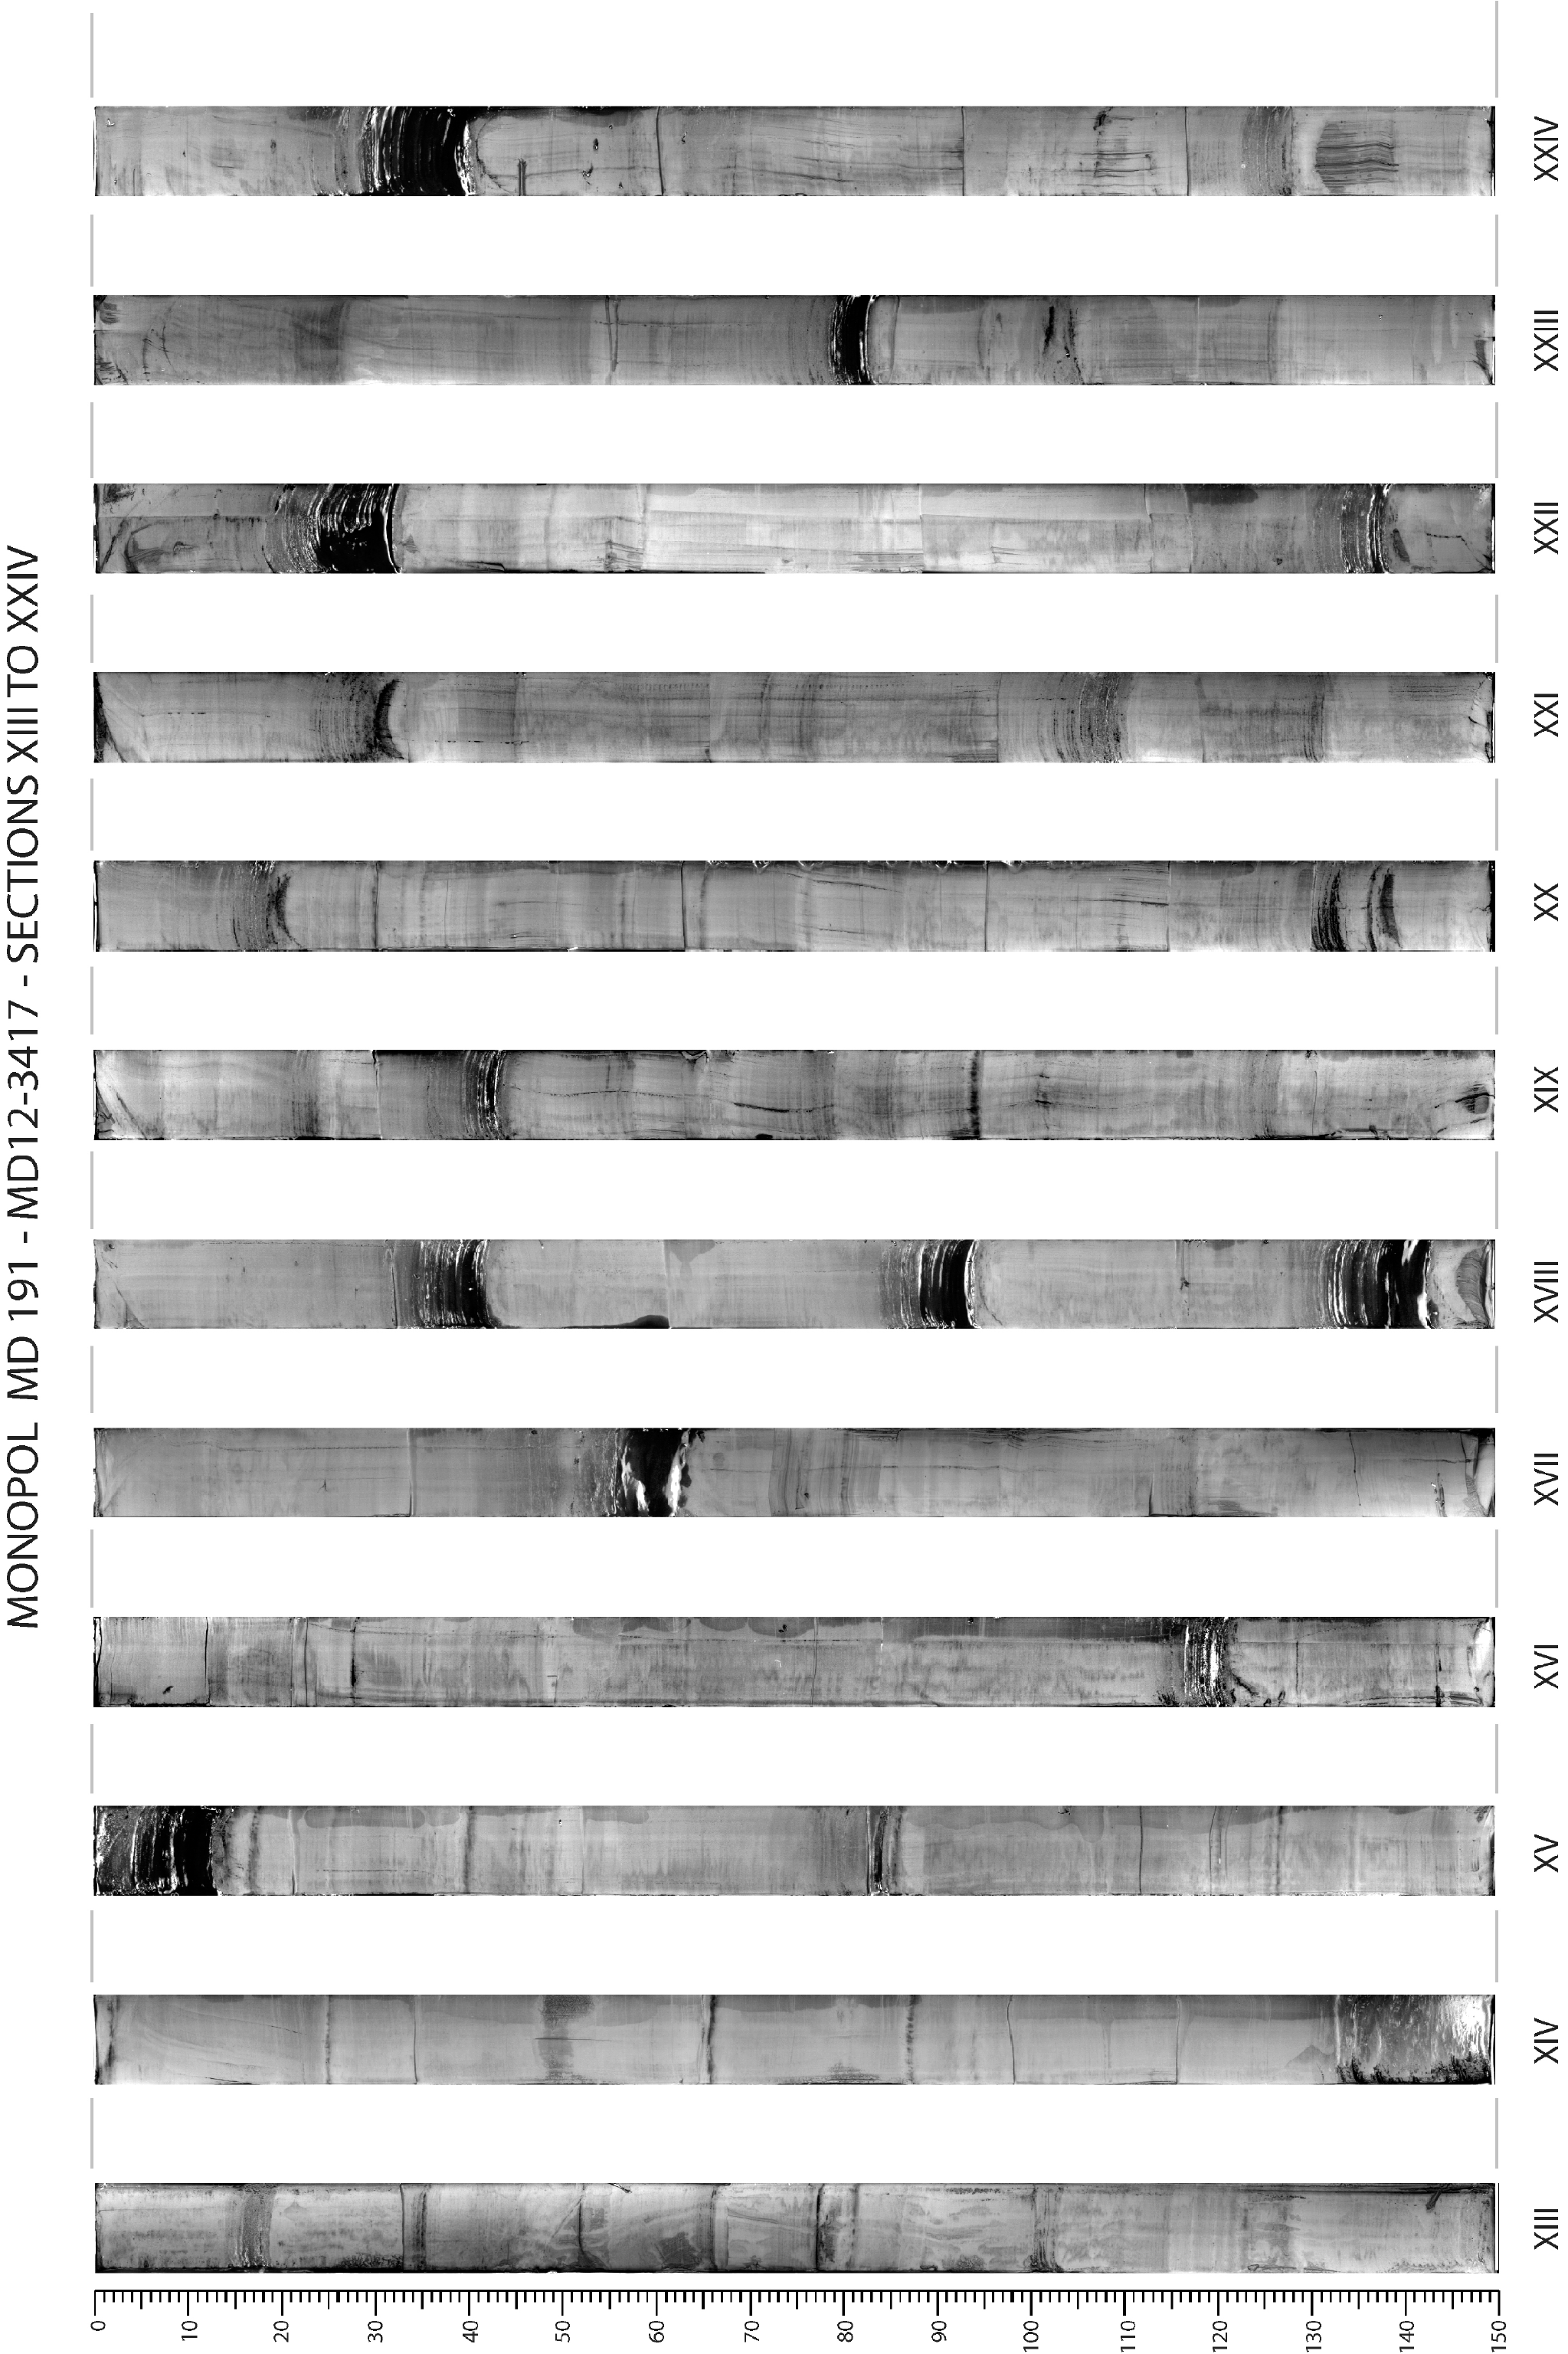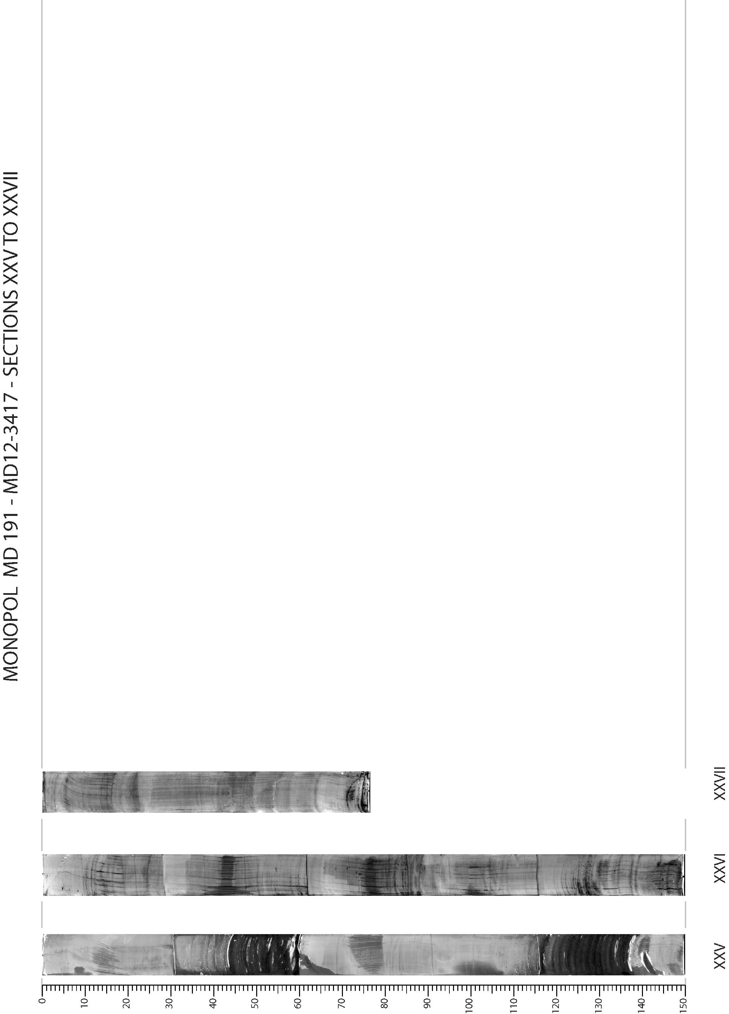
MD191 – MONOPOL | Station: MONO 8

PHYSICAL PROPERTIES OF CALYPSO MD12-3417

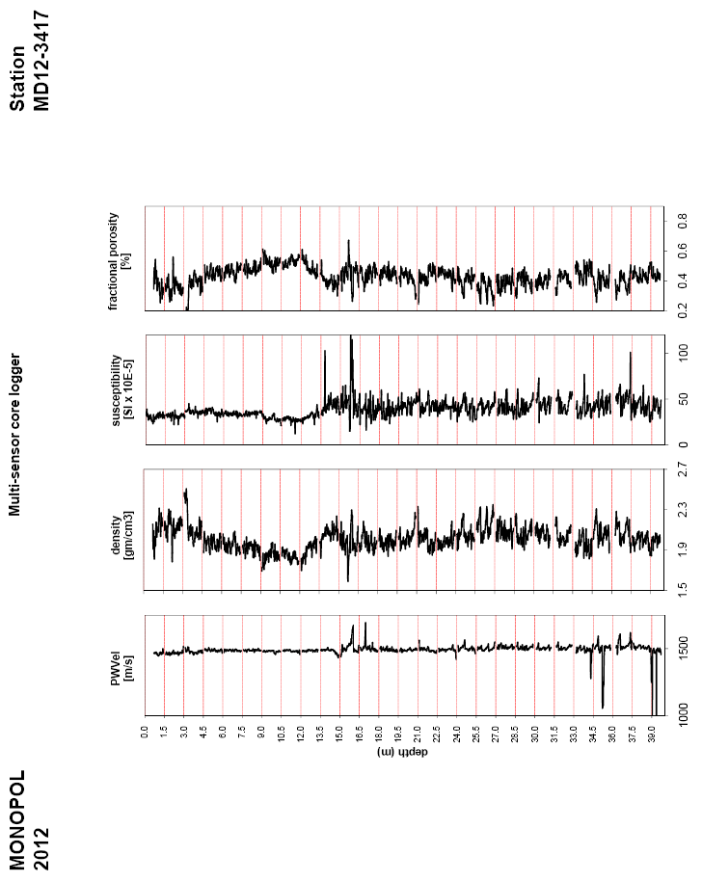
empty
empty

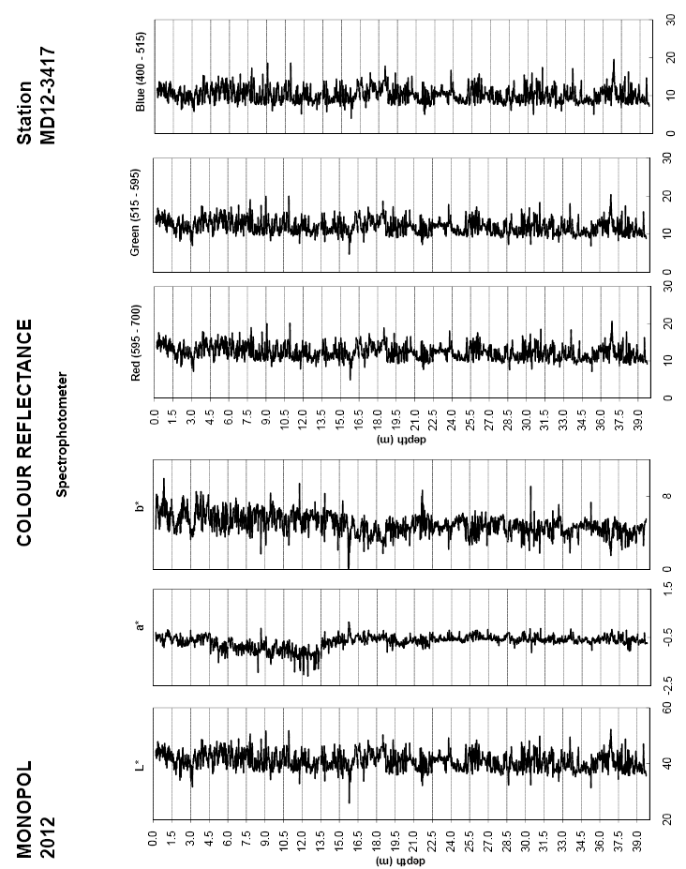

Figure: Physical properties and color reflectance of Calypso core MD12-3417

MD191 – MONOPOL | Station: MONO 8

SEDIMENTOLOGY OF CALYPSO MD12-3417
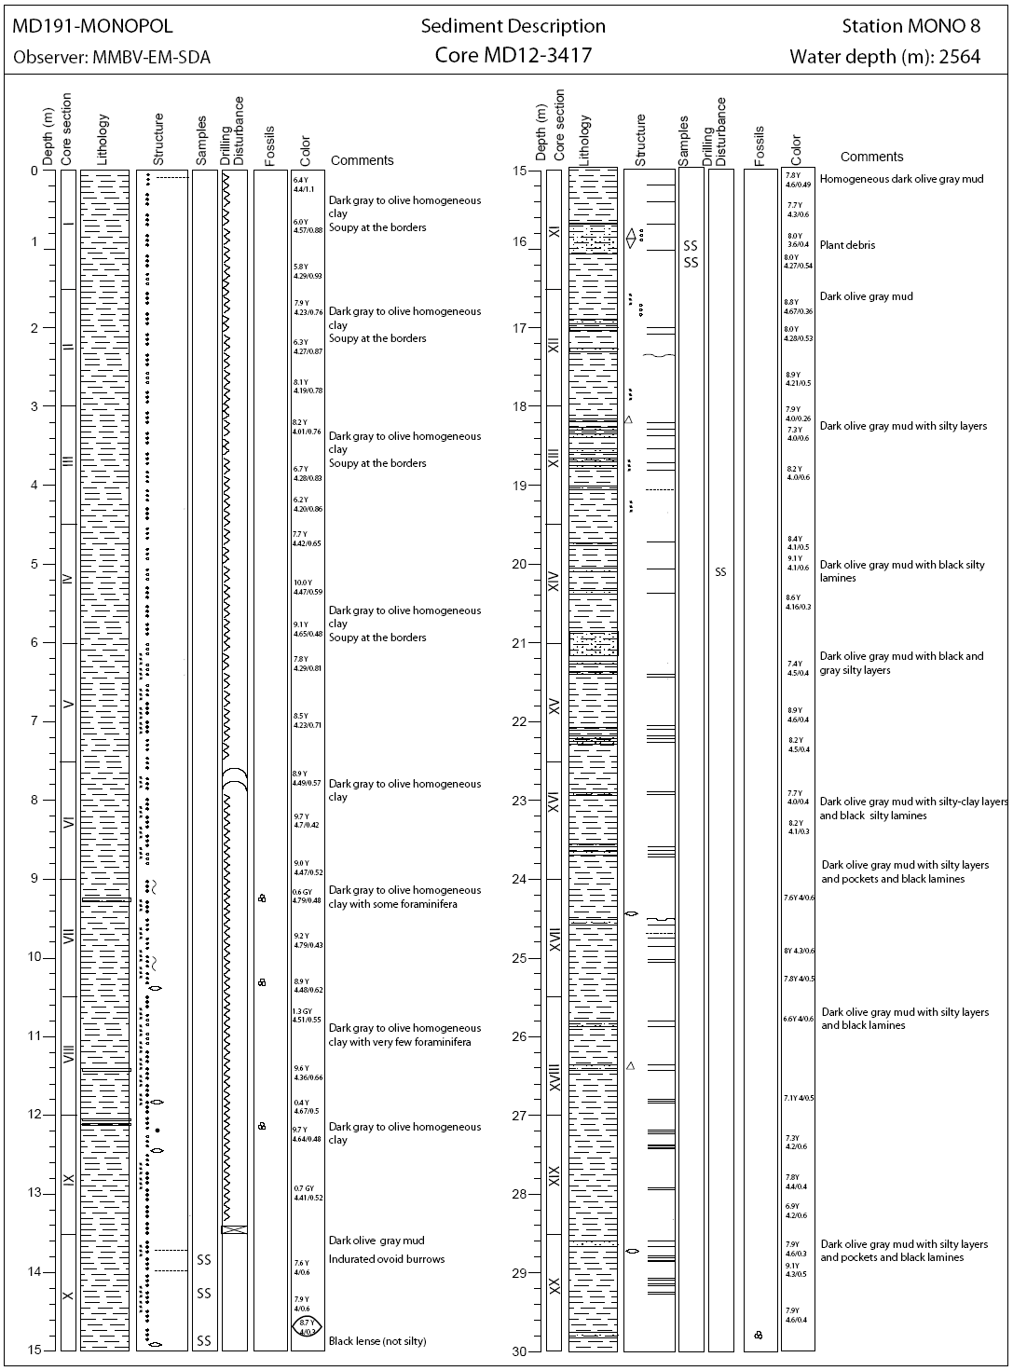

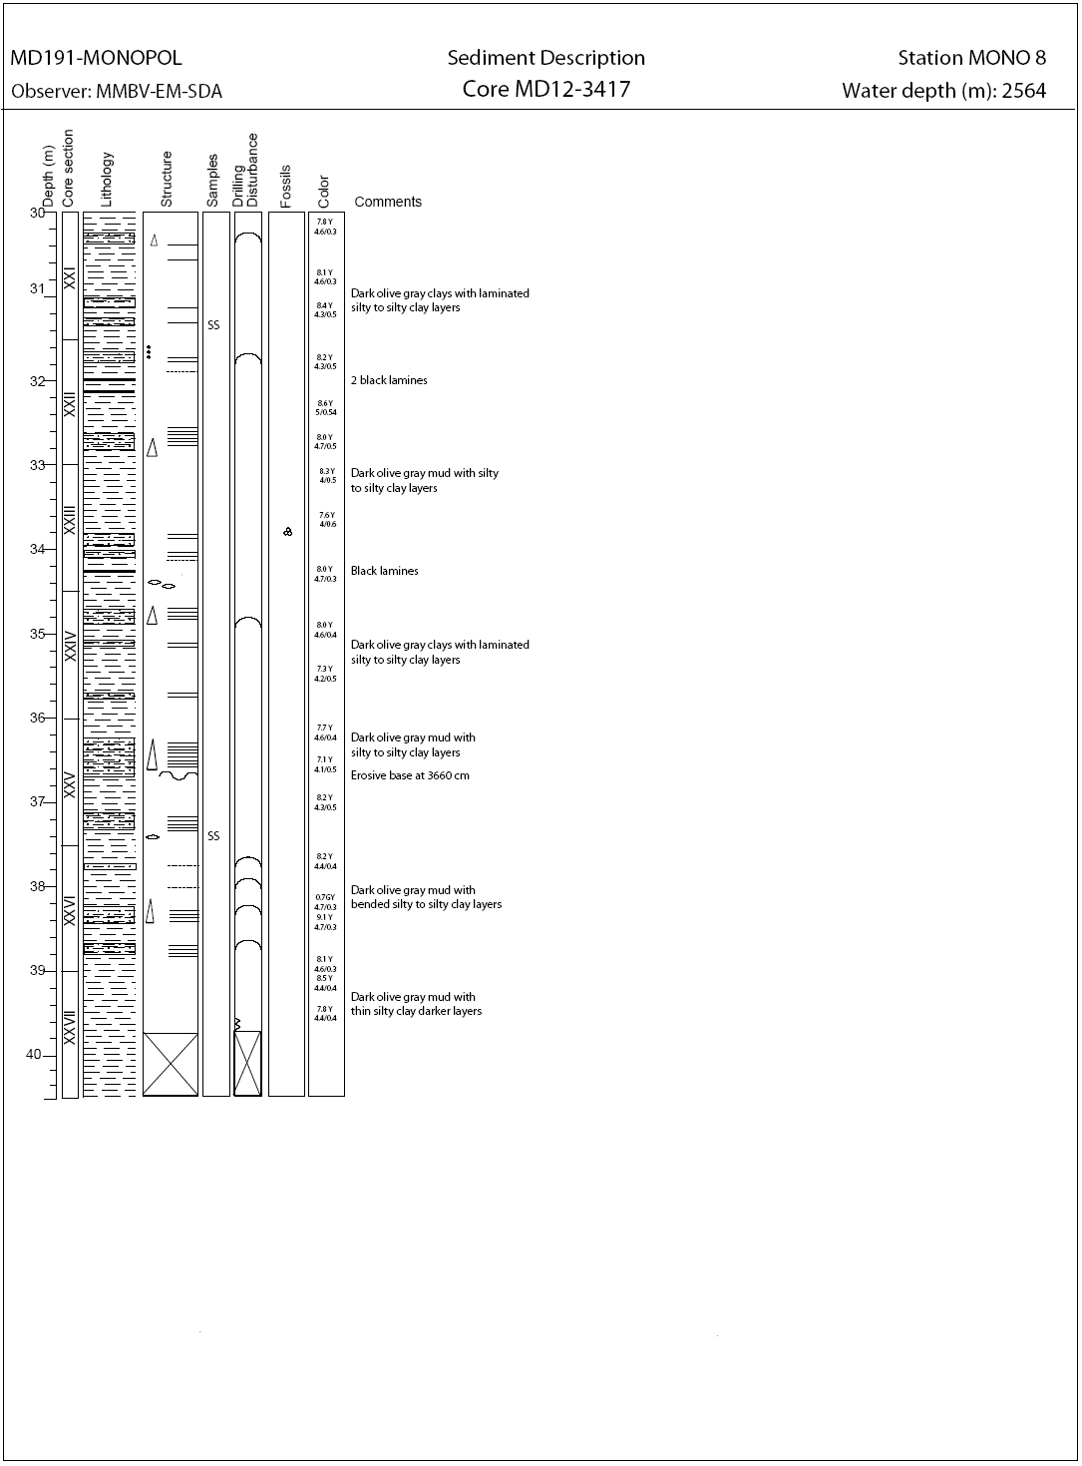

MD191 – MONOPOL | Station: MONO 8

SECTIONS INFORMATIONS OF CALYPSO MD12-3422

Core MD12-3422 |  |  |  |  |  |  | MONOPOL -MD191
Section | Top depth (cm) | Bottom depth (cm) | Real length of section (cm) | Observations
I | 0 | 150 | 150.7
II | 150 | 300 | 151.1
III | 300 | 450 | 149.9
IV | 450 | 600 | 151
V | 600 | 750 | 150.6
VI | 750 | 900 | 150.2
VII | 900 | 1050 | 150.8 | 1044-1051: polystyren
VIII | 1050 | 1200 | 148.9
IX | 1200 | 1350 | 150.3
X | 1350 | 1500 | 150.2
XI | 1500 | 1650 | 150.7
XII | 1650 | 1800 | 150.5
XIII | 1800 | 1950 | 150.9
XIV | 1950 | 2100 | 150.4
XV | 2100 | 2250 | 150.4
XVI | 2250 | 2400 | 150.4
XVII | 2400 | 2550 | 150.4 | MSCL didn’ttouch : 2518 - 2550
XVIII | 2550 | 2700 | 150 | 2677-2686 and 2695-2700: polystyren (don’ttouchsince 2640)
XIX | 2700 | 2850 | 150.9
XX | 2850 | 3000 | 133.2 | Section XX + calib afterwards

MD191 – MONOPOL | Station: MONO 8

PICTURES OF CALYPSO MD12-3422
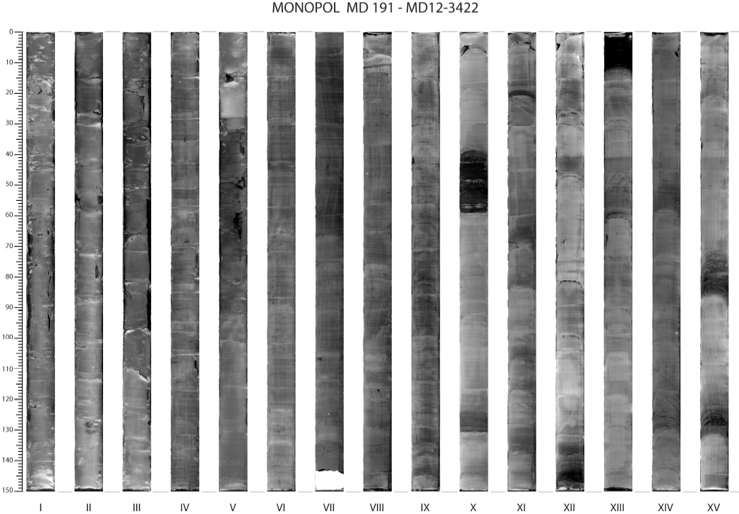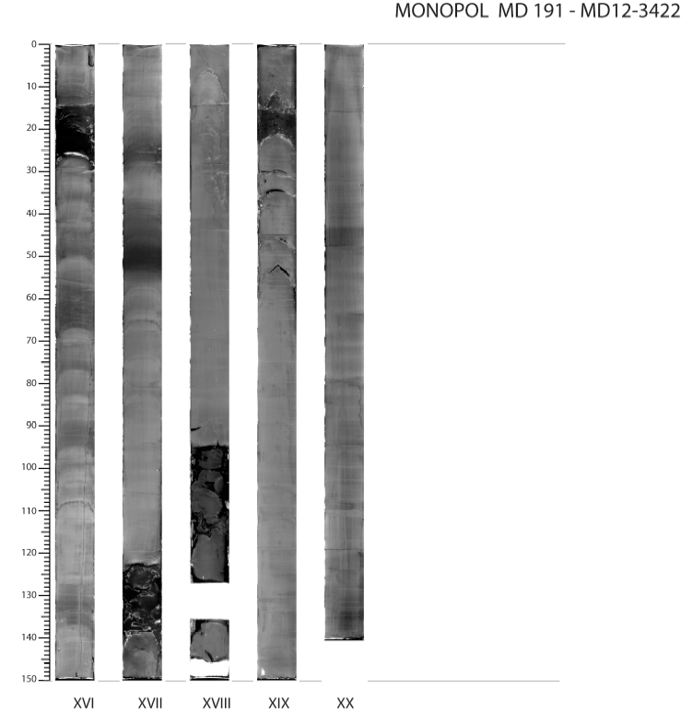
MD191 – MONOPOL | Station: MONO 8

PHYSICAL PROPERTIES OF CALYPSO MD12-3422

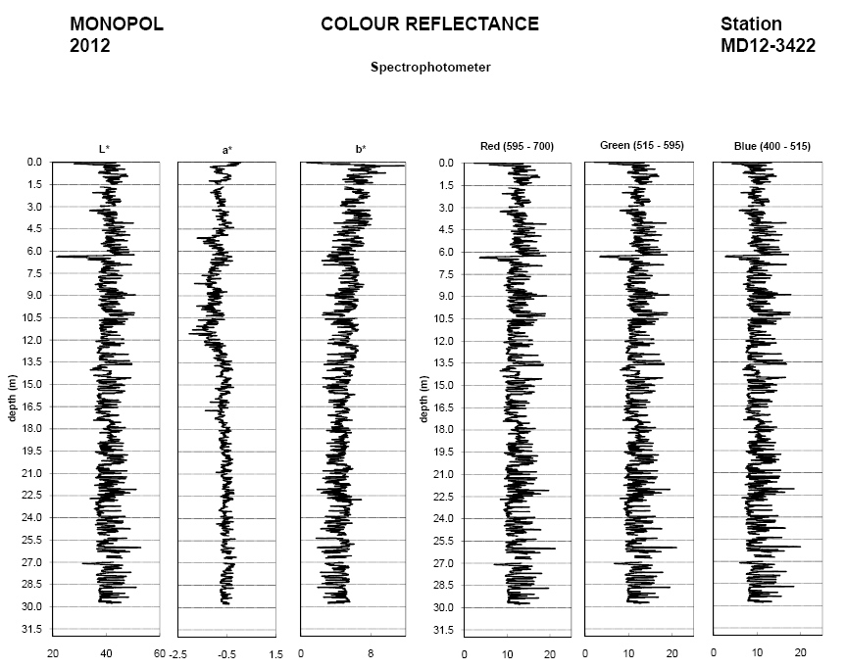

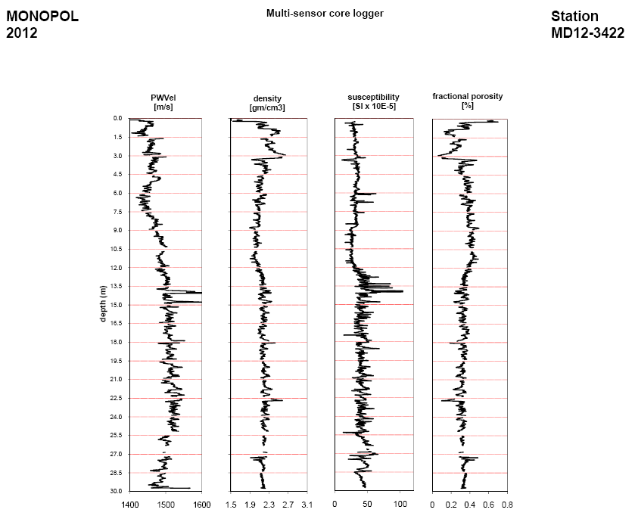
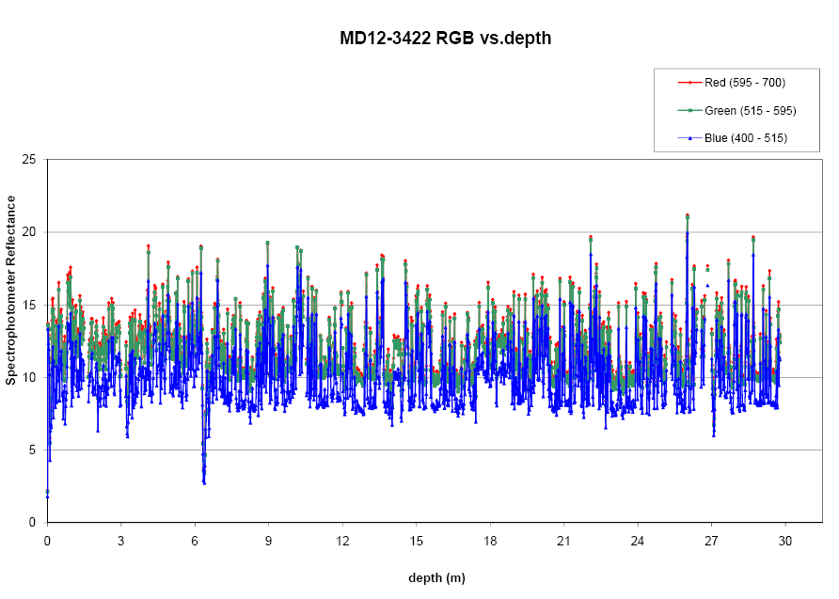
Figure: Physical properties and color reflectance of Calypso core MD12-3422

MD191 – MONOPOL | Station: MONO 8

SEDIMENTOLOGY OF CALYPSO CORE MD12-3422
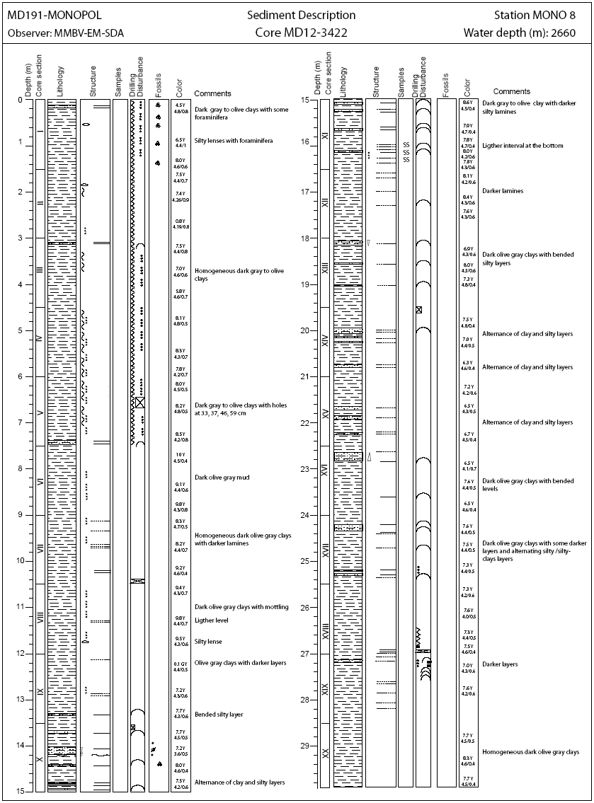

MD191 – MONOPOL | Station: MONO 8

SECTIONS INFORMATIONS OF CASQ MD12-3416-CQ

Number of layers (2 or 3):
Sketch of the core section, defining the location of liners A, B, C, D, E, F:

F
E
D
C
A
B

Liner A : large size (12 cm)
Liners B, D, E, F : medium size (6 cm)
Liners C : small U-channels

SECTIONS INFORMATIONS OF CASQ MD12-3416 CQ
Core MD12-3416 CQ |  |  |  |  |  |  | MONOPOL -MD191
Section | Top depth (cm) | Bottom depth (cm) | Real length of section (cm) | Observations
Ia+Ib | 0 | 150 | 149 | -
II | 150 | 300 | 149.5 | -
III | 300 | 450 | 149.8 | -
IV | 450 | 600 | 149.9 | -
V | 600 | 698 | 149.7 | -

MD191 – MONOPOL | Station: MONO 8

PICTURES OF CASQ MD12-3416-CQ

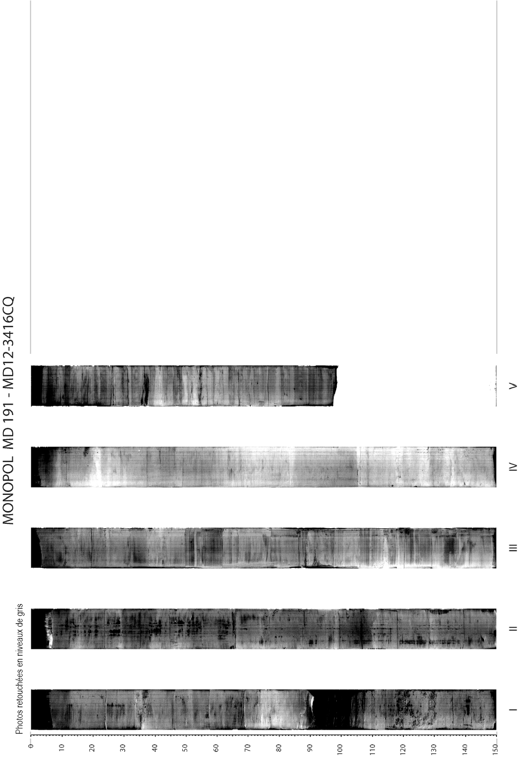
MD191 – MONOPOL | Station: MONO 8

PHYSICAL PROPERTIES OF CASQ MD12-3416 -CQ
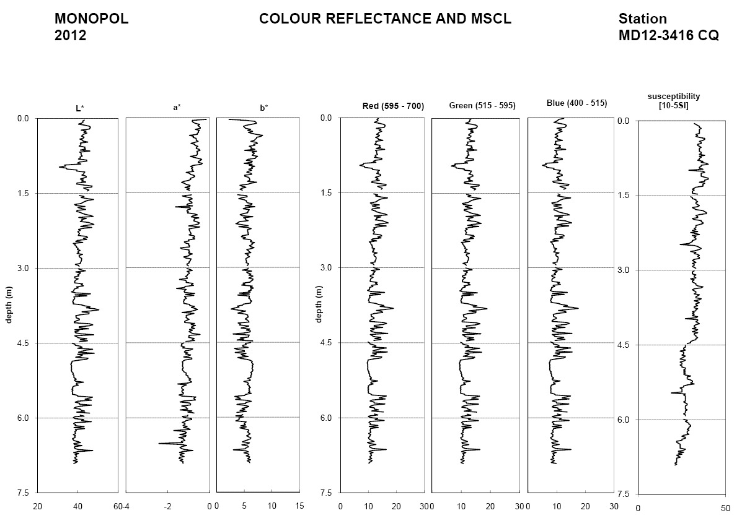
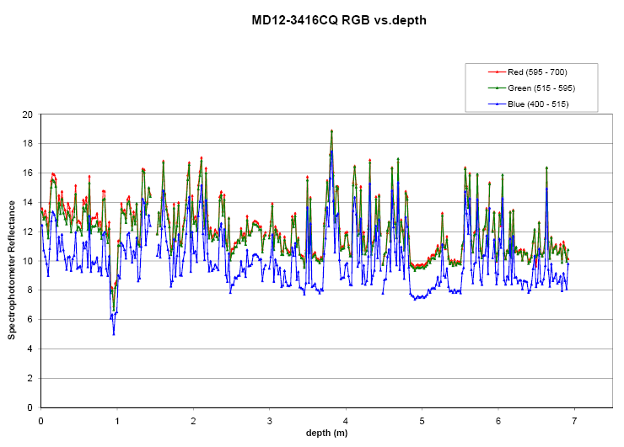
Figure: Color reflectance and physical properties of CASQ core MD12-3416 CQ

MD191 – MONOPOL | Station: MONO 8

SEDIMENTOLOGY OF CASQ CORE MD12-3416-CQ

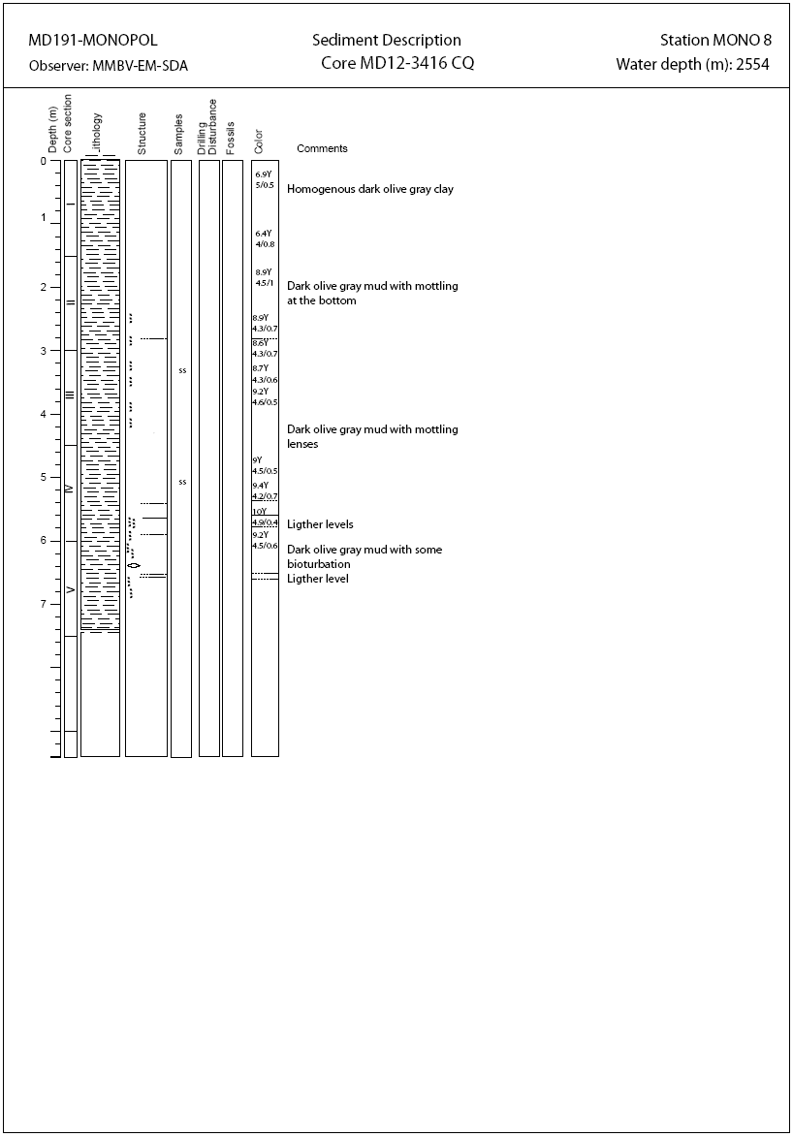

MD191 – MONOPOL | Station: MONO 8

SECTIONS INFORMATIONS OF CASQ MD12-3418-CQ

Number of layers (2 or 3):
Sketch of the core section, defining the location of liners A, B, C, D, E, F, G:

E
G
F
D
C
A
B

Liner A, D, F : large size
Liners B, E, G : medium size
Liners C : small U-channel

SECTIONS INFORMATIONS OF CASQ MD12-3418 CQ
Core MD12-3418 CQ |  |  |  |  |  |  | MONOPOL -MD191
Section | Top depth (cm) | Bottom depth (cm) | Real length of section (cm) | Observations
Ia+Ib | 0 | 150 | 149.2 | -
II | 150 | 300 | 149.2 | -
III | 300 | 450 | 149.4 | -
IV | 450 | 600 | 149.4 | -
V | 600 | 750 | 149.6 | -
VI | 750 | 852 | 149.1 | -

MD191 – MONOPOL | Station: MONO 8

PICTURES OF CASQ MD12-3418-CQ
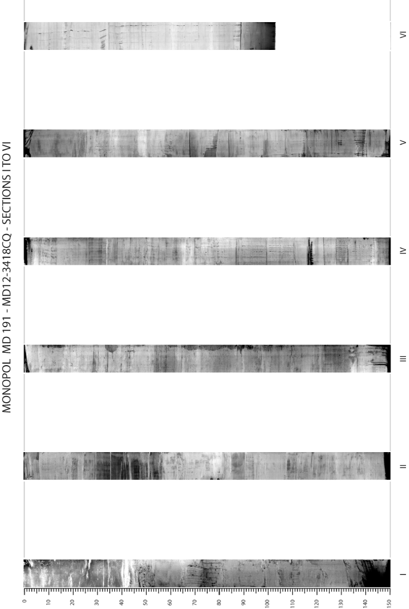
MD191 – MONOPOL | Station: MONO 8

PHYSICAL PROPERTIES OF CASQ MD12-3418 -CQ
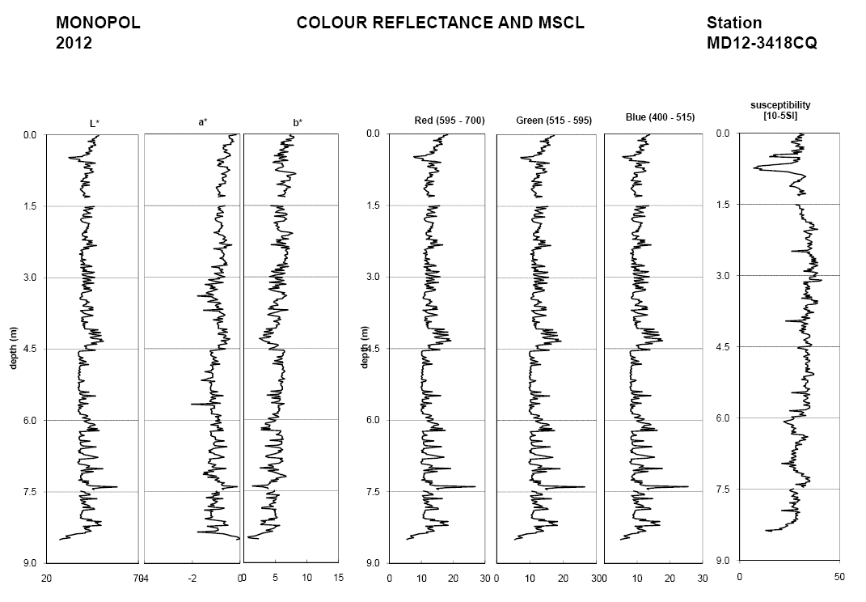
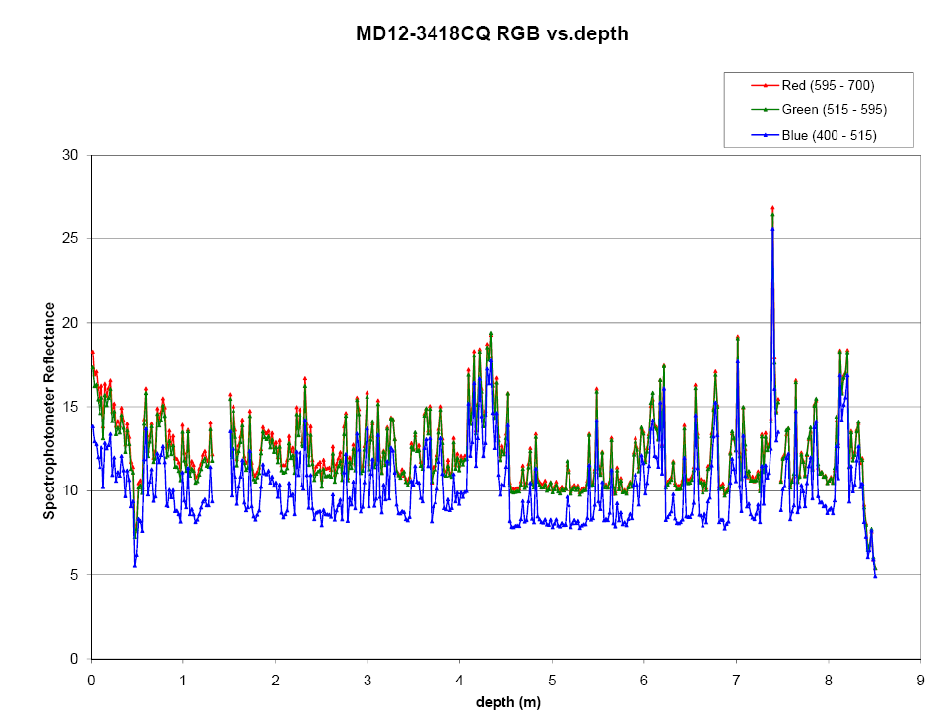
MD191 – MONOPOL | Station: MONO 8

SEDIMENTOLOGY OF CASQ CORE MD12-3418-CQ
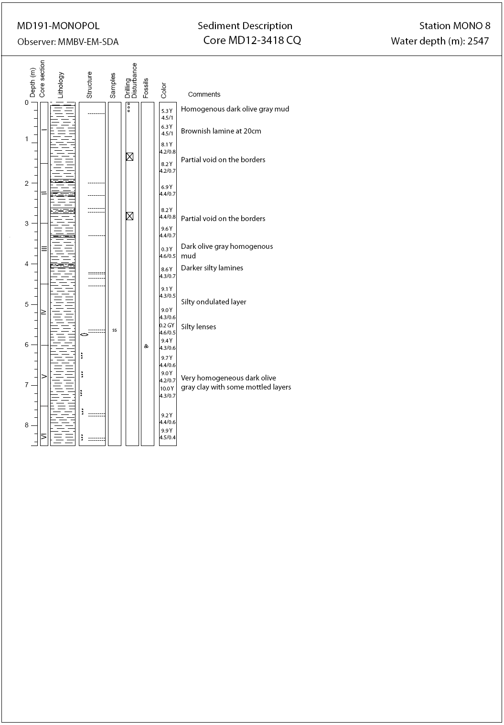

MD191 – MONOPOL | Station: MONO 8

COMPARISON OF CASQ CORE MD12-3416-CQ and MD12-3418-CQ

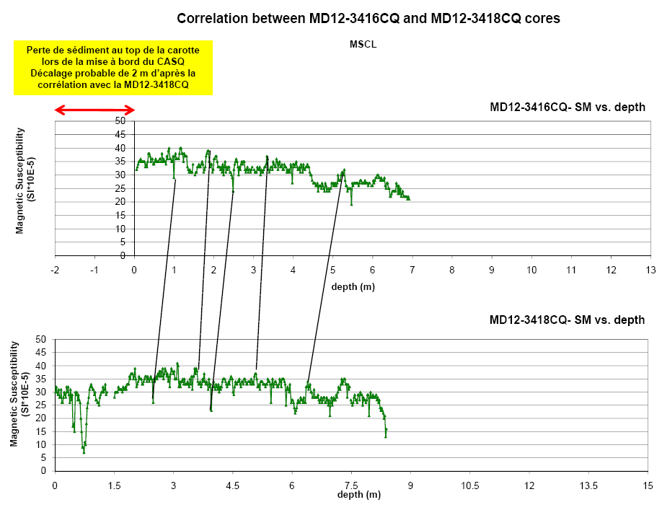

MD191 – MONOPOL | Station: MONO 8

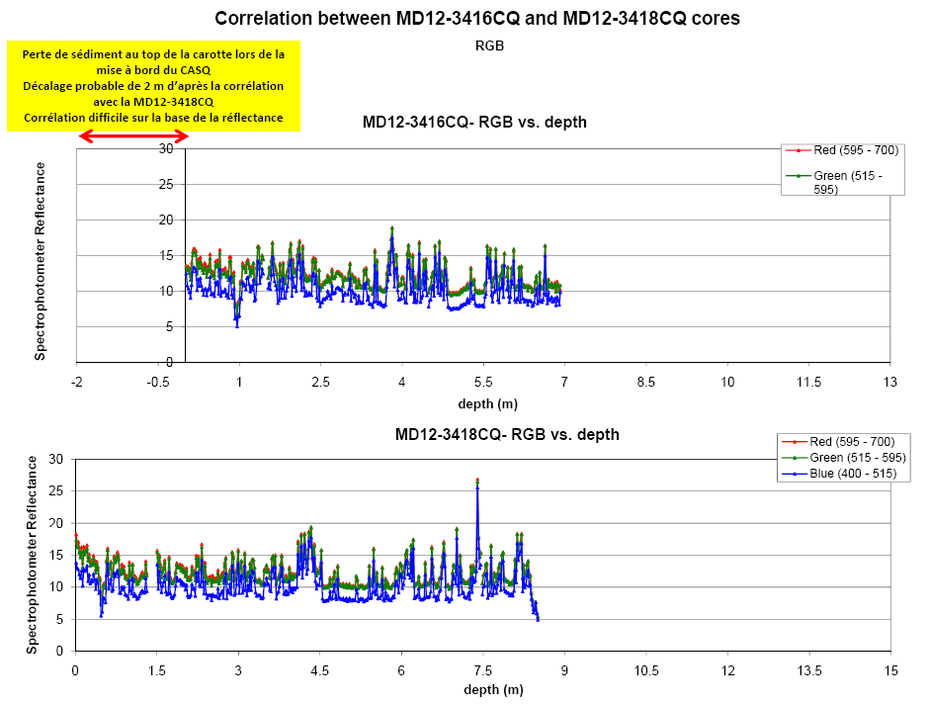

MD191 – MONOPOL | Station: MONO 8

COMPARISON OF CASQ CORE MD12-3416-CQ and CALYPSO CORE MD12-3417



