MD191 – MONOPOL | Station: MONO 6

STATION SUMMARY

Date and time approaching site: 1/6/2012 – 22:40 (TU)
Date and time ending station activity: 1/6/2012 – 14:00 (TU)
Latitude: 18°02.84’N Longitude: 89°22.96’E Water depth (m): ?
Short area description:
Northern part of the Bay of Bengal.

Activity on station |  | Core identification
Calypso corer | No
Casq | No
Multi-corer | Yes | MD191-MC-MONO6
Temp/Salinity/Fluorometry on coring device | No
CTD / Water sampling (rosette) | Yes
Deep In situ pump | No
Plankton net | Yes

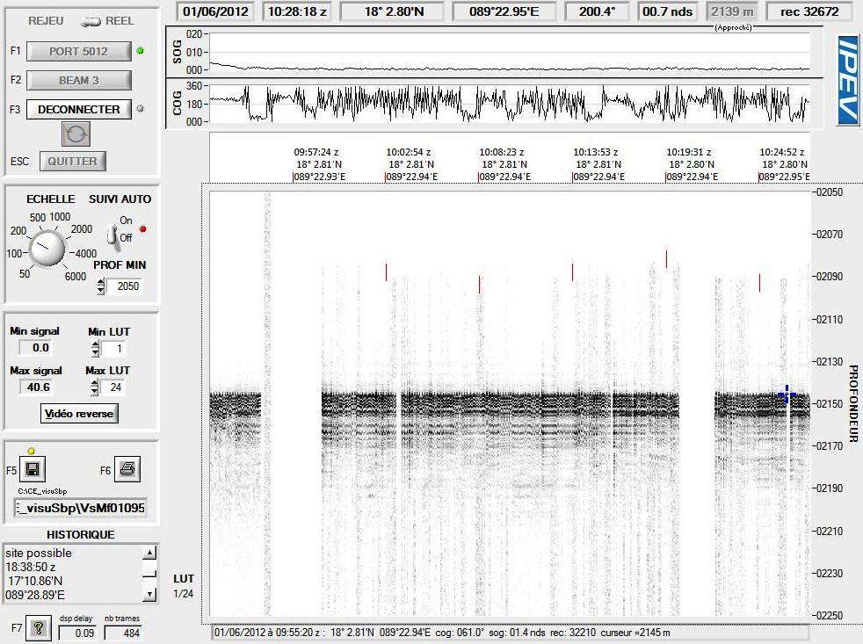
Figure: 3.5 kHz profile across station MONO 6.

MD191 – MONOPOL | Station: MONO 6

MULTI-CORER OPERATION: MD191-MC-MONO6

Coring site information | Latitude (°N): | 18°02.85’ N
 | Longitude (°E): | 89°22.98’ E
 | Water depth (m): | 2140
Coring operation | Time multi corer starts descent: | 13:30
 | Time at bottom: | 14:13
 | Time corer on deck: | 15:00
Length of sediments (cm) | Tube 1 | -
 | Tube 2 | -
 | Tube 3 | -
 | Tube 4 | -

General observations / incidents: empty for all tubes.

MD191 – MONOPOL | Station: MONO 6

CTD/ROSETTE/ISP OPERATION

CTD/Rosette site information | Latitude (°N): | 18°02.84’N
 | Longitude (°E): | 89°22.96’E
CTD/Rosette operation | Time CTD/rosette starts descent: | 11:11
 | Time on bottom:
 | Time on deck: | 11:45
Depth of Water sampling | Bottle 1 | 2128
 | Bottle 2 | 2118
 | Bottle 3 | 2100
 | Bottle 4 | 2000
 | Bottle 5 | 1800
 | Bottle 6 | 1500
 | Bottle 7 | 1300
 | Bottle 8 | 1101
 | Bottle 9 | -
 | Bottle 10 | 900
 | Bottle 11 | 700
 | Bottle 12 | 500
 | Bottle 13 | -
 | Bottle 14 | 400
 | Bottle 15 | 300
 | Bottle 16 | 200
 | Bottle 17 | 129
 | Bottle 18 | 99
 | Bottle 19 | 98
 | Bottle 20 | 71
 | Bottle 21 | -
 | Bottle 22 | 30
 | Bottle 23 | 17
 | Bottle 24 | 5

General observations / incidents:

MULTI-NET OPERATION
 |  | First deployement | Second deployement
Coring site information | Latitude (°N): | 18°02.83’N | 18°02.83’N
 | Longitude (°E): | 89°22.89’E | 89°22.89’E
Coring operation | Time start operation: | 12:10 | 12:55
 | Time net on deck: | 12:50 | 13:09
Depth of multinet collection (m) | Collector 1 | 400-180 | 100-80
 | Collector 2 | 180-100 | 80-60
 | Collector 3 | 100-80 | 60-40
 | Collector 4 | 80-60 | 40-20
 | Collector 5 | 60-0 | 20-0
General observations / incidents:

MD191 – MONOPOL | Station: MONO 6

CTD PROFILES

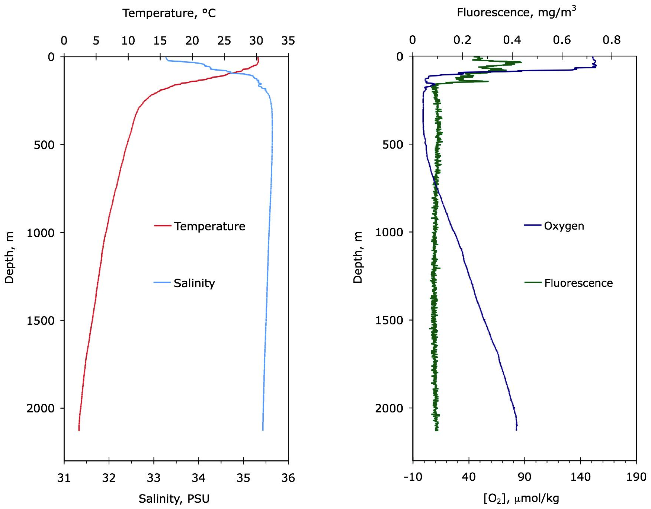

Figure: Temperature, salinity, fluorescence and dissolved oxygen profiles at site MONO 6.

