MD191 – MONOPOL | Station: MONO 4

STATION SUMMARY

Date and time approaching site: 30/5/2012 – 20:34 (TU)
Date and time ending station activity: 31/5/2012 – 23:58 (TU)
Latitude: 17°10.94’N Longitude: 89°28.92’E Water depth (m): 2368
Short area description:
Northern part of the Bay of Bengal.

Activity on station |  | Core identification
Calypso corer | Yes | MD12-3412
Casq | Yes | MD12-3411 CQ
Multi-corer | Yes | MD191-MC-MONO1
Temp/Salinity/Fluorometry on coring device | No
CTD / Water sampling (rosette) | Yes
Deep In situ pump | Yes
Plankton net | Yes

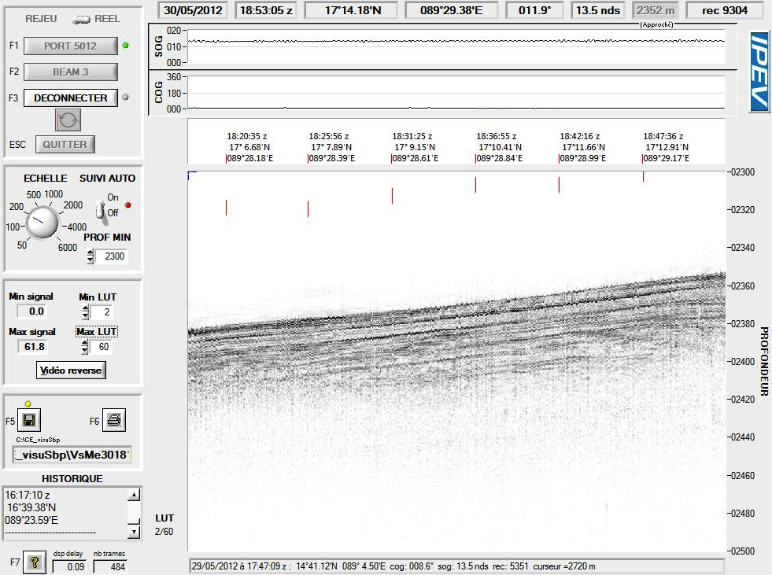
Figure: 3.5 kHz profile across station MONO 4.

MD191 – MONOPOL | Station: MONO 4

CALYPSO CORING OPERATION: MD12-3412

Coring site information | Latitude (°N): | 17°10.94’N
 | Longitude (°E): | 89°29.91’E
 | Water depth (m): | 2367
Calypso corer settings | Core length (m): | 35
 | Empty weight in water (t): | 7.26
 | Free fall (m): | 2.75
 | Length piston cable (m): | 47.15
Coring operation | Time corer starts descent: | 10:31
 | Time triggering: | 11:29
 | Length cable (m): | 2333
 | Maximum tension (t) | 13.9
 | Time corer on deck: | 13:23
Result coring operation | Total weight in water (t) | 7.57
 | Length of sediment (m) | 32.23

Figure: Core level versus in situ sediment depth, CINEMA reconstructions for core MD12-3412.
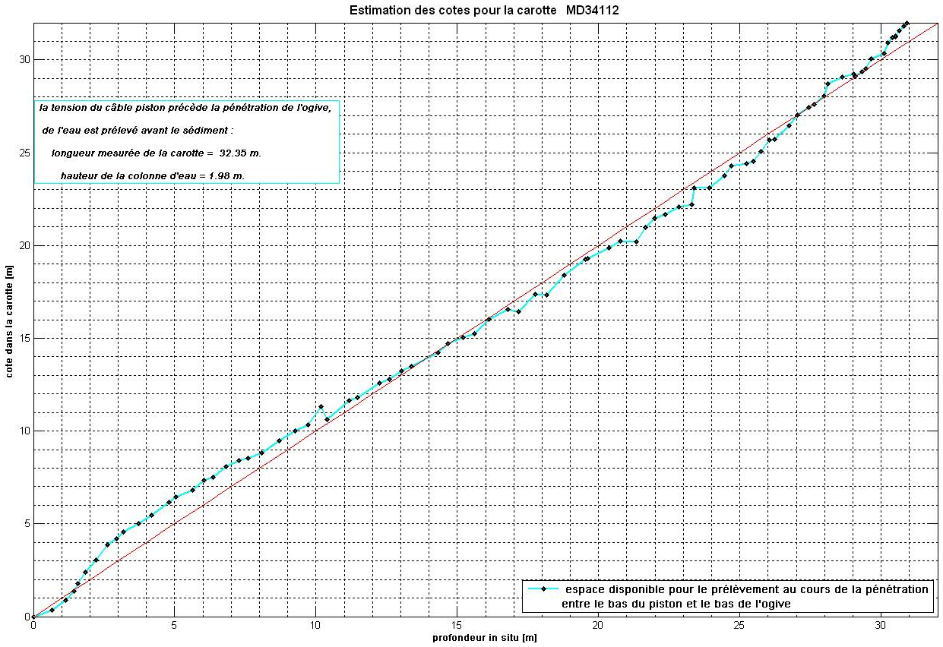

MD191 – MONOPOL | Station: MONO 4

CASQ CORING OPERATION: MD12-3411-CQ

Coring site information | Latitude (°N): | 17°10.94’N
 | Longitude (°E): | 89°28.92’E
 | Water depth (m): | 2354
Casq corer settings | Core length (m): | 12
 | Empty weight in water (t): | 6.7
Coring operation | Time corer starts descent: | 0:12
 | Time on bottom: | 3:03
 | Maximum tension (t) | 12
 | Time corer on deck: | 5:30
Result coring operation | Total weight in water (t) | 7.3
 | Length of sediment (m) | 9.20
General observations / incidents: Problème de treuil 0:45-2:41 => CaSq bloqué à 1327m. Puis problème de truncanage pour remontée du CaSq sur le pont. Pas d’incidence sur le résultat du carottage.

MULTI-CORER OPERATION: MD191-MC-MONO4

Coring site information | Latitude (°N): | 17°10.95’ N
 | Longitude (°E): | 89°28.93’ E
 | Water depth (m): | 2368
Coring operation | Time multi corer starts descent: | 7:00
 | Time at bottom: | 7:34
 | Time corer on deck: | 8:15
Length of sediments (cm) | Tube 1 | 28
 | Tube 2 | 23
 | Tube 3 | 28
 | Tube 4 | 26
General observations / incidents:

MD191 – MONOPOL | Station: MONO 4

CTD/ROSETTE (shallow) OPERATION

CTD/Rosette site information | Latitude (°N): | 17°13.25’ N
 | Longitude (°E): | 89°28.47’ E
CTD/Rosette operation | Time CTD/rosette starts descent: | 15:53
 | Time on bottom:
 | Time on deck: | 23:30
Depth of Water sampling | Bottle 1 | 2329
 | Bottle 2 | 2301
 | Bottle 3 | 2299
 | Bottle 4 | 1900
 | Bottle 5 | 1899
 | Bottle 6 | 1501
 | Bottle 7 | 1499
 | Bottle 8 | 1000
 | Bottle 9 | -
 | Bottle 10 | 998
 | Bottle 11 | 750
 | Bottle 12 | 749
 | Bottle 13 | -
 | Bottle 14 | 501
 | Bottle 15 | 500
 | Bottle 16 | 300
 | Bottle 17 | 200
 | Bottle 18 | 199
 | Bottle 19 | 150
 | Bottle 20 | 99
 | Bottle 21 | 98
 | Bottle 22 | 50
 | Bottle 23 | 49
 | Bottle 24 | 5

MD191 – MONOPOL | Station: MONO 4-b

CTD/ROSETTE/ISP OPERATION

CTD/Rosette site information | Latitude (°N): | 17°13.25’ N
 | Longitude (°E): | 89°28.47’ E
CTD/Rosette operation | Time CTD/rosette starts descent: | 15:53
 | Time on bottom:
 | Time on deck: | 23:30
Depth of Water sampling | Bottle 1 | 2329
 | Bottle 2 | 2301
 | Bottle 3 | 2299
 | Bottle 4 | 1900
 | Bottle 5 | 1899
 | Bottle 6 | 1501
 | Bottle 7 | 1499
 | Bottle 8 | 1000
 | Bottle 9 | -
 | Bottle 10 | 998
 | Bottle 11 | 750
 | Bottle 12 | 749
 | Bottle 13 | -
 | Bottle 14 | 501
 | Bottle 15 | 500
 | Bottle 16 | 300
 | Bottle 17 | 200
 | Bottle 18 | 199
 | Bottle 19 | 150
 | Bottle 20 | 99
 | Bottle 21 | 98
 | Bottle 22 | 50
 | Bottle 23 | 49
 | Bottle 24 | 5

In-Situ Pumping (ISP)
Water depth of pumping (m) | 1000
Filtered volume (L) | 512
Filter | Nucleopore 0.4 um
General observations / incidents:

MULTI-NET OPERATION
 |  | First deployement | Second deployement
Coring site information | Latitude (°N): | 17°10.94’ N | 17°10.94’ N
 | Longitude (°E): | 89°28.92’ E | 89°28.92’ E
Coring operation | Time start operation: | 21:35 | 22:24
 | Time net on deck: | 22:20 | 22:45
Depth of multinet collection (m) | Collector 1 | 400-180 | 103-81
 | Collector 2 | 180-100 | 81-60
 | Collector 3 | 100-80 | 60-40
 | Collector 4 | 80-60 | 40-20
 | Collector 5 | 60-0 | 20-0
General observations / incidents:

MD191 – MONOPOL | Station: MONO 4

CTD PROFILES (shallow)
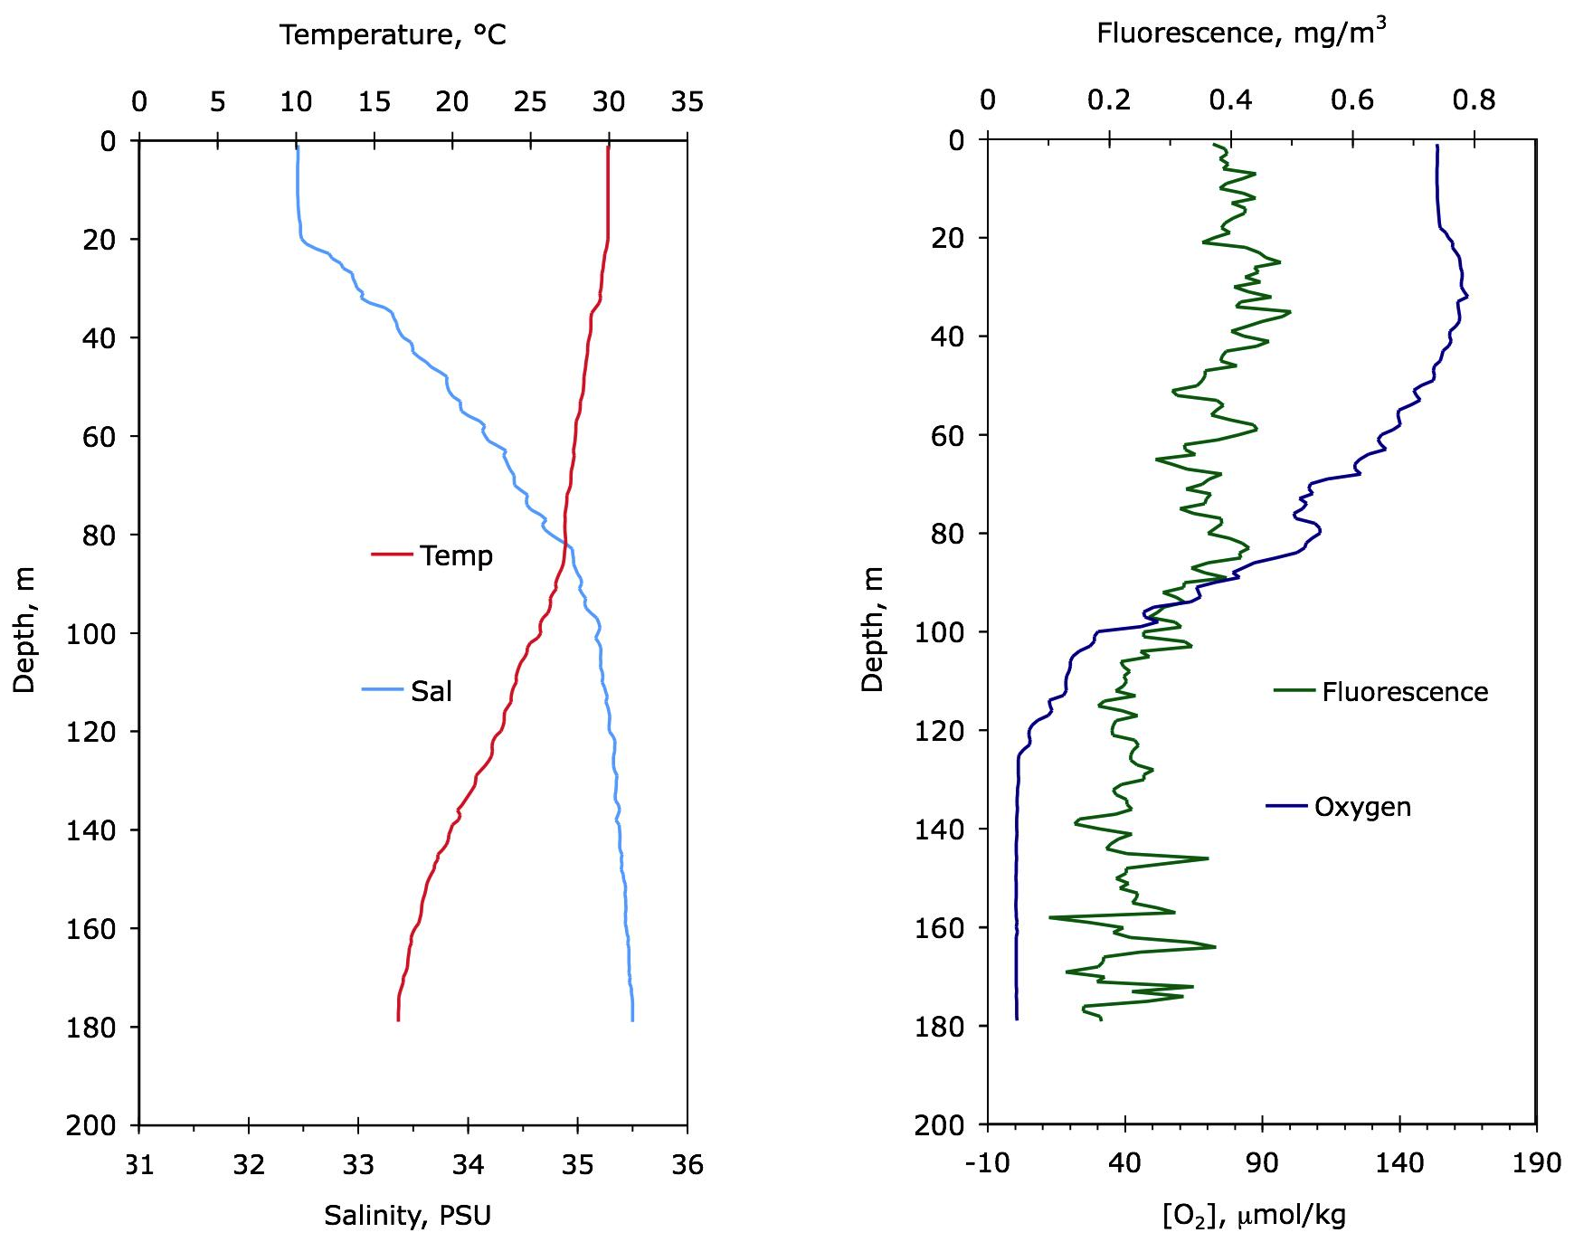

Figure: Temperature, salinity, fluorescence and dissolved oxygen profiles at site MONO 4.

MD191 – MONOPOL | Station: MONO 4-b

CTD PROFILES

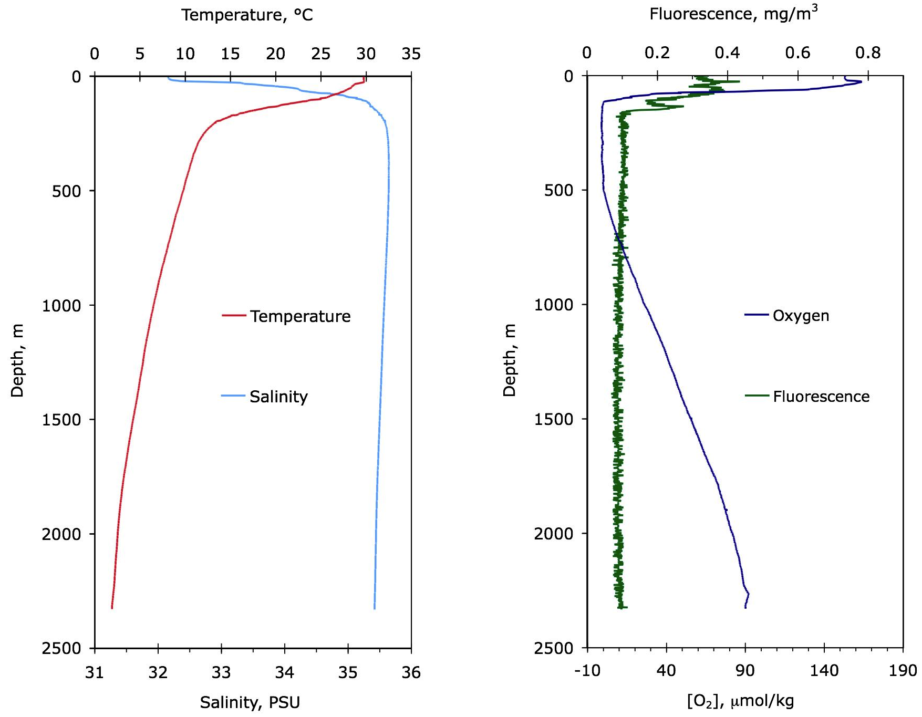

Figure: Temperature, salinity, fluorescence and dissolved oxygen profiles at site MONO 4-b.

MD191 – MONOPOL | Station: MONO 4

SECTIONS INFORMATIONS OF CALYPSO MD12-3412

Core MD12-3412 |  |  |  |  |  |  | MONOPOL -MD191
Section | Top depth (cm) | Bottom depth (cm) | Real length of section (cm) | Observations
I | 0 | 150 | 149.6
II | 150 | 300 | 150.8
III | 300 | 450 | 150.1
IV | 450 | 600 | 150.4
V | 600 | 750 | 150
VI | 750 | 900 | 150.8
VII | 900 | 1050 | 150.3
VIII | 1050 | 1200 | 150.4
IX | 1200 | 1350 | 150.5
X | 1350 | 1500 | 150.4 | Polystyren: 1401-1490
XI | 1500 | 1650 | 150.2
XII | 1650 | 1800 | 150.4
XIII | 1800 | 1950 | 150
XIV | 1950 | 2100 | 149.1
XV | 2100 | 2250 | 151.9
XVI | 2250 | 2400 | 151.7
XVII | 2400 | 2550 | 152.2
XVIII | 2550 | 2700 | 152.2
XIX | 2700 | 3850 | 150.8
XX | 2850 | 3000 | 150.5
XXI | 3000 | 3150 | 150.9
XXII | 3150 | 3221 | 71.9

MD191 – MONOPOL | Station: MONO 4

PICTURES OF CALYPSO MD12-3412

MD191 – MONOPOL | Station: MONO 4

PHYSICAL PROPERTIES OF CALYPSO MD12-3412

Figure: Physical properties and color reflectance of Calypso core MD12-3412.
MD191 – MONOPOL | Station: MONO 4

SEDIMENTOLOGY OF CALYPSO MD12-3412

MD191 – MONOPOL | Station: MONO 4

SECTIONS INFORMATIONS OF CASQ MD12-3411-CQ

Number of layers (2 or 3): 2
Sketch of the core section, defining the location of liners A, B, C, D, E:

A
B

C
D
E

G
F

Liner A : large size (12 cm)
Liners B, E, F, G : medium size (6 cm)
Liners C, D : small U-channels

MD12-3411-CQ
Section | Theorical | Real length (cm)
I | 0-150 | 150.2
II | 150-300 | 150.1
III | 300-450 | 150.1
IV | 450-600 | 150.3
V | 600-750 | 150
VI | 750-900 | 150
VII | 900-913 | 13
VIII
IX

MD191 – MONOPOL | Station: MONO 4

PICTURES OF CASQ MD12-3411-CQ

MD191 – MONOPOL | Station: MONO 4

PHYSICAL PROPERTIES OF CASQ MD12-3411-CQ
MD191 – MONOPOL | Station: MONO 4

SEDIMENTOLOGY OF CASQ CORE MD12-3411-CQ

MD191 – MONOPOL | Station: MONO 4

COMPARISON CASQ MD12-3411-CQ vs CALYPSO MD12-3412

